1. Create a virtual network with 2 subnets. Each subnet should have 16 Ips only.

Sign in to the [Azure portal](https://portal.azure.com/).

In the portal, search for and select **Virtual networks**.

On the **Virtual networks** page, select **Create**.

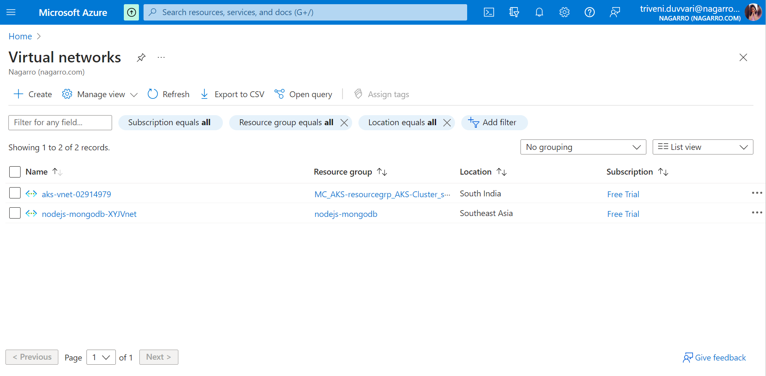

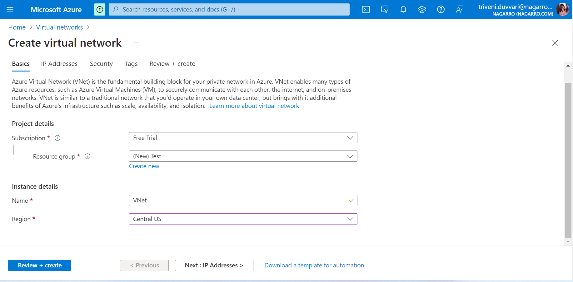

Fill the details in basic and click on Next : IP Addresses

Fill the address Space

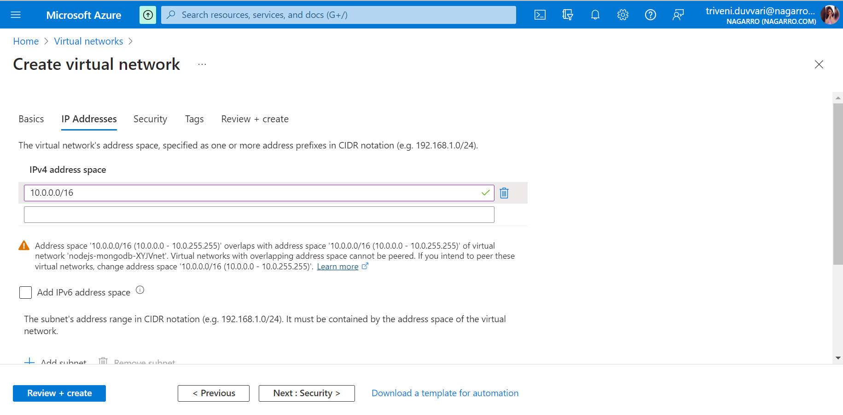

Click on Add Subnet to Create subnet, Here we have to create two subnets with 16 lps for that we need to set subnet address range accordingly.

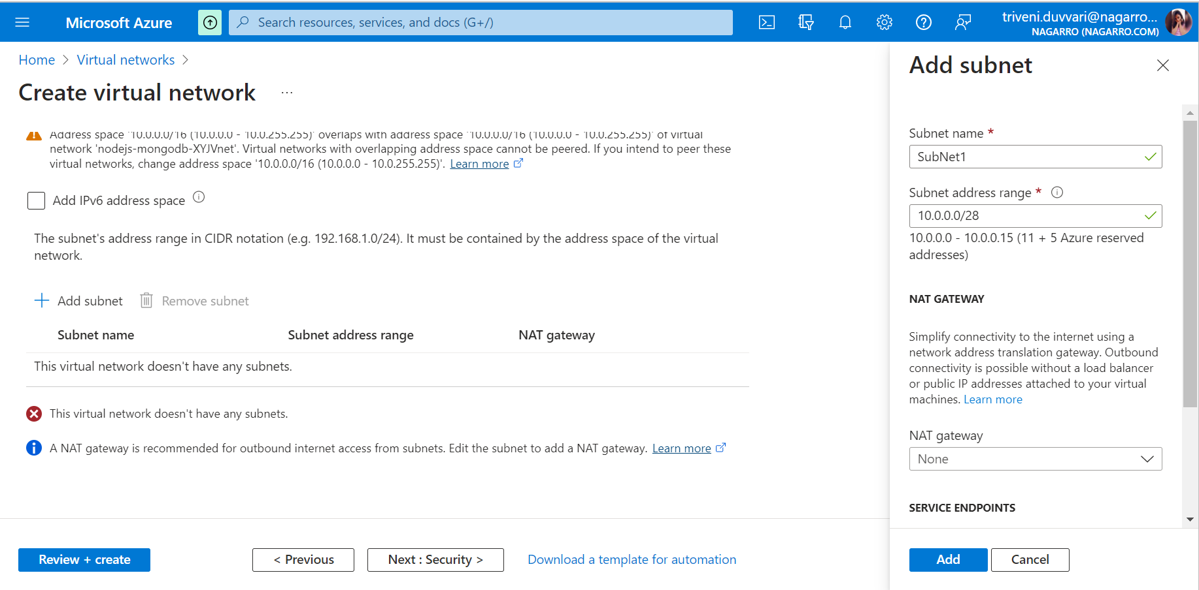

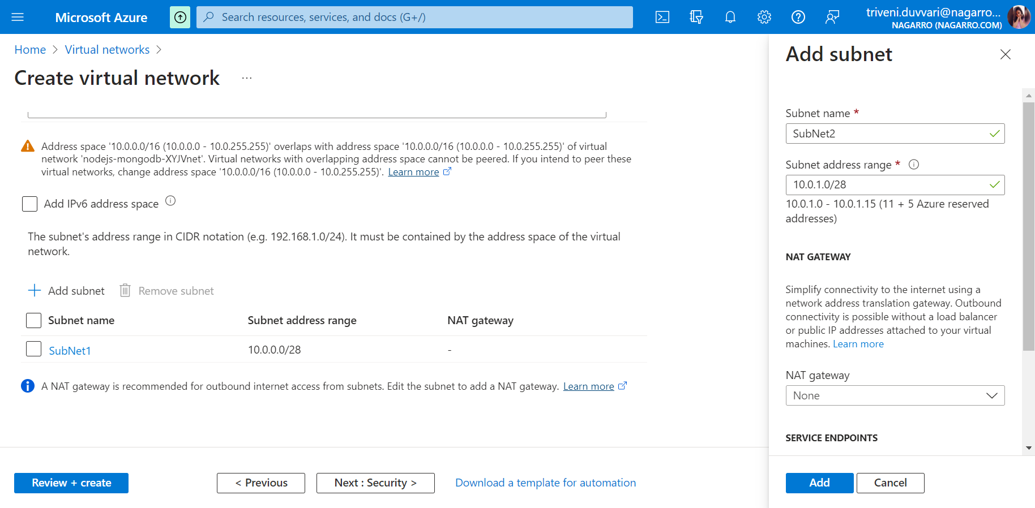

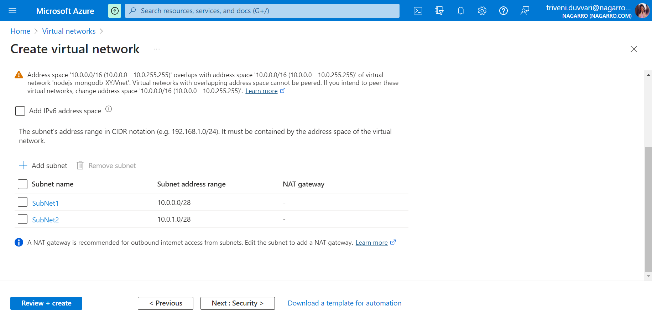

After creating subnets, click on Next : Security

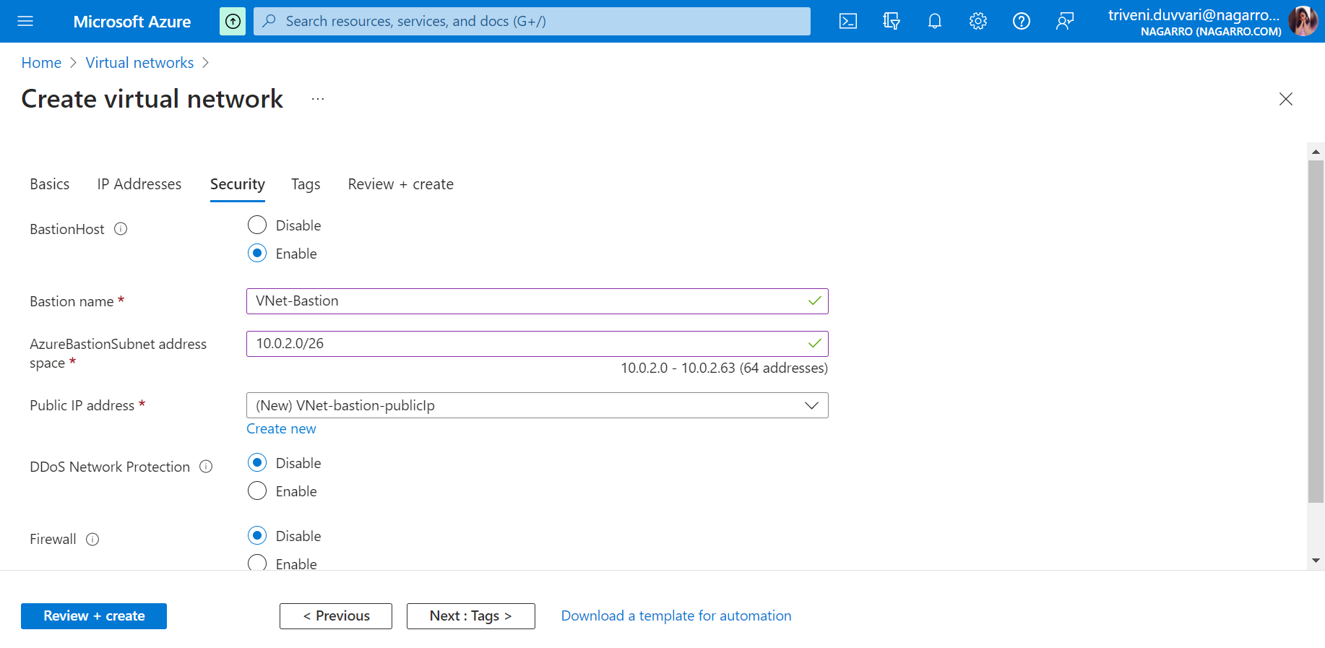

Make Bastion Host Enable and fill details accordingly.

After that click on Review + Click

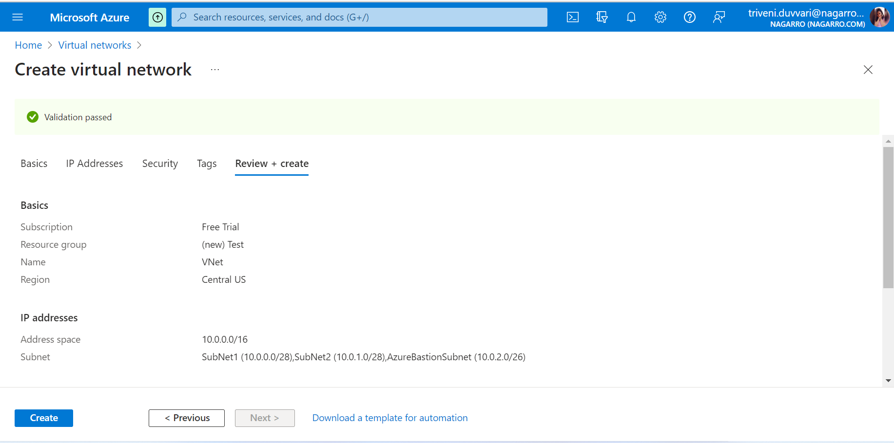

Click on Create

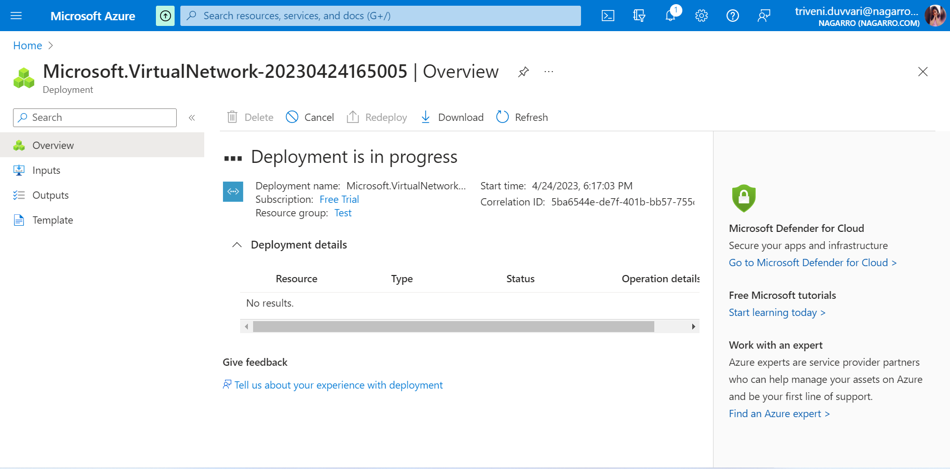

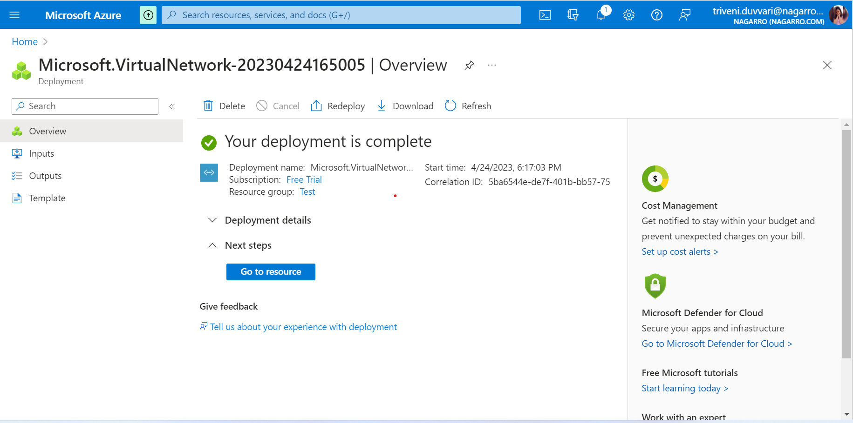

1. Inside one of the subnets, create a VM and deploy an application code inside it and it should leverage the database on the cloud (any existing application created by you before)

Sign in to the [Azure portal](https://portal.azure.com/).

In the portal, search for and select virtual machines.

On the virtual machines page, select **Create**.

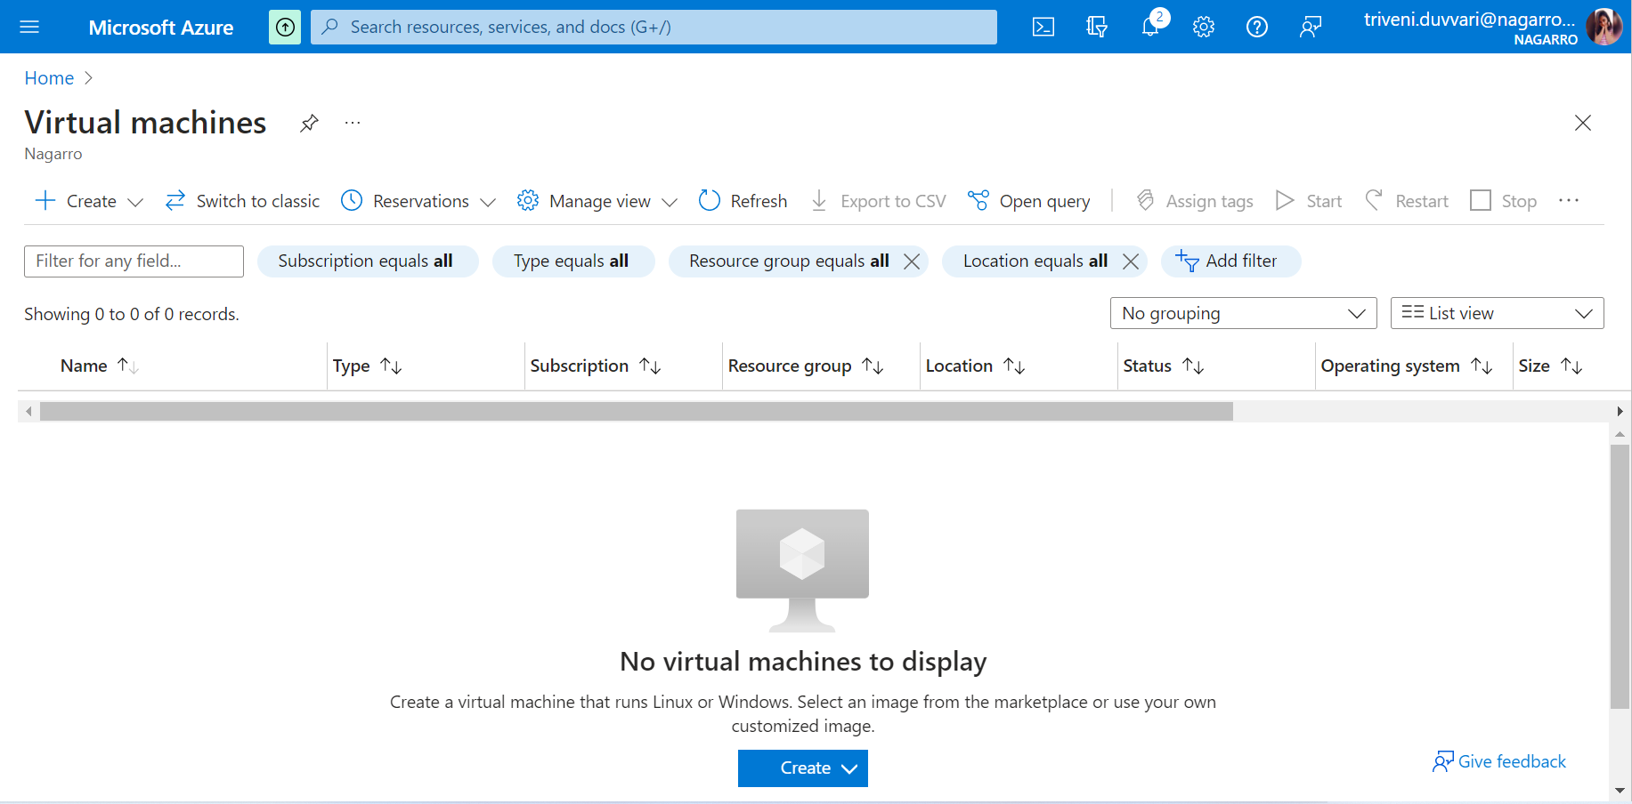

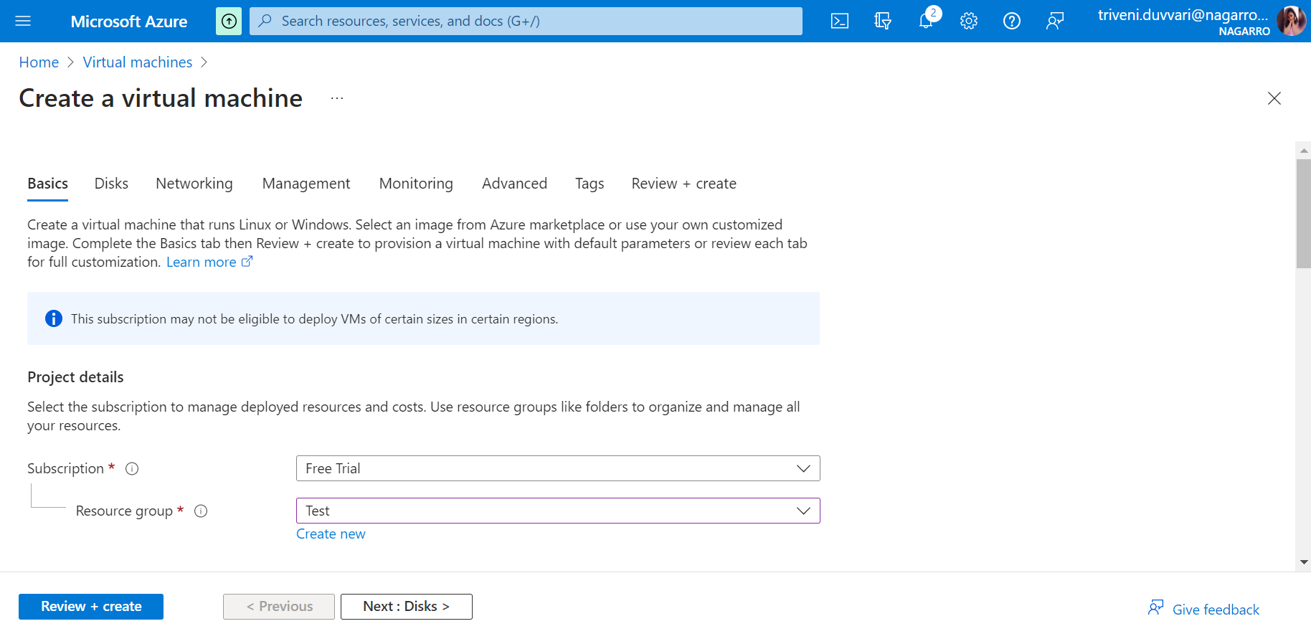

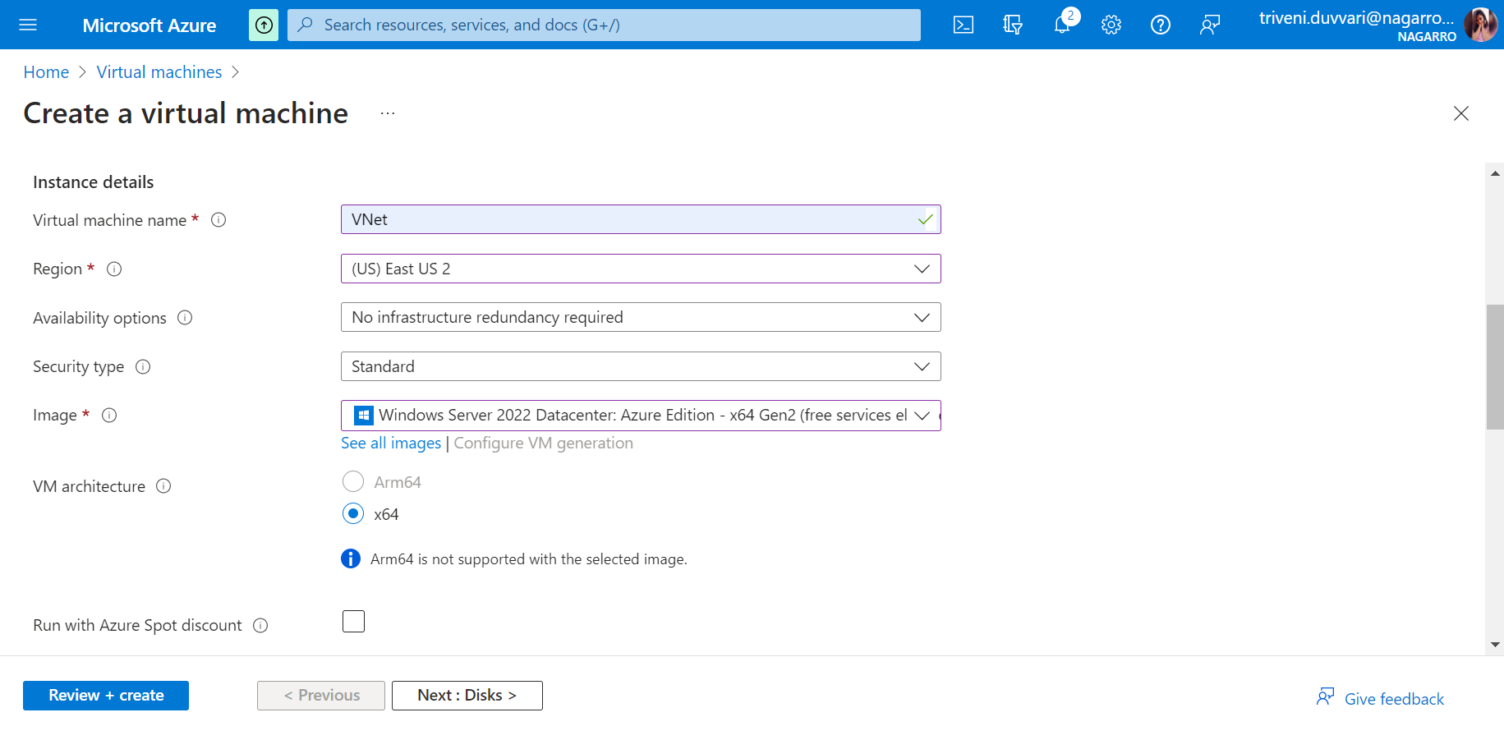

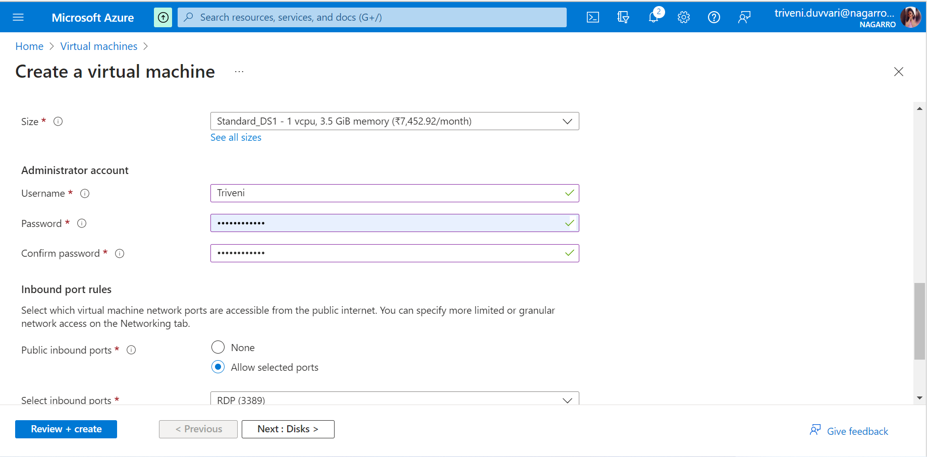

Fill the basic information and go to networking tab

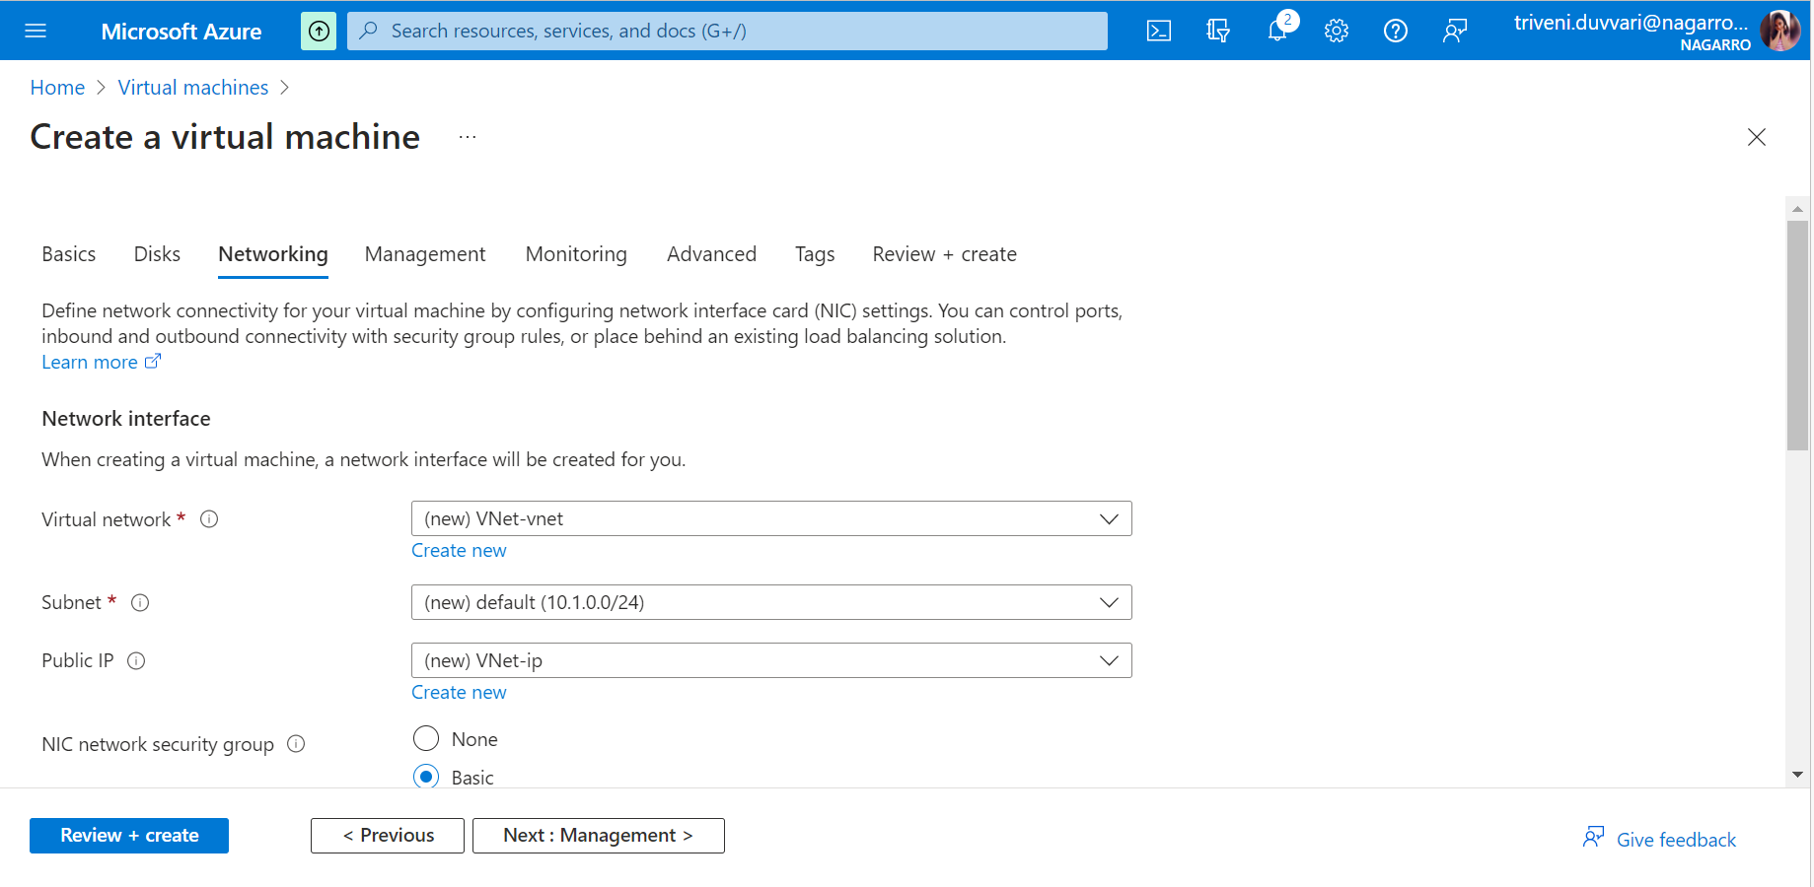

For creating VM in particular subnet, Both the VM and Subnet should be in same region

Click on Review + create

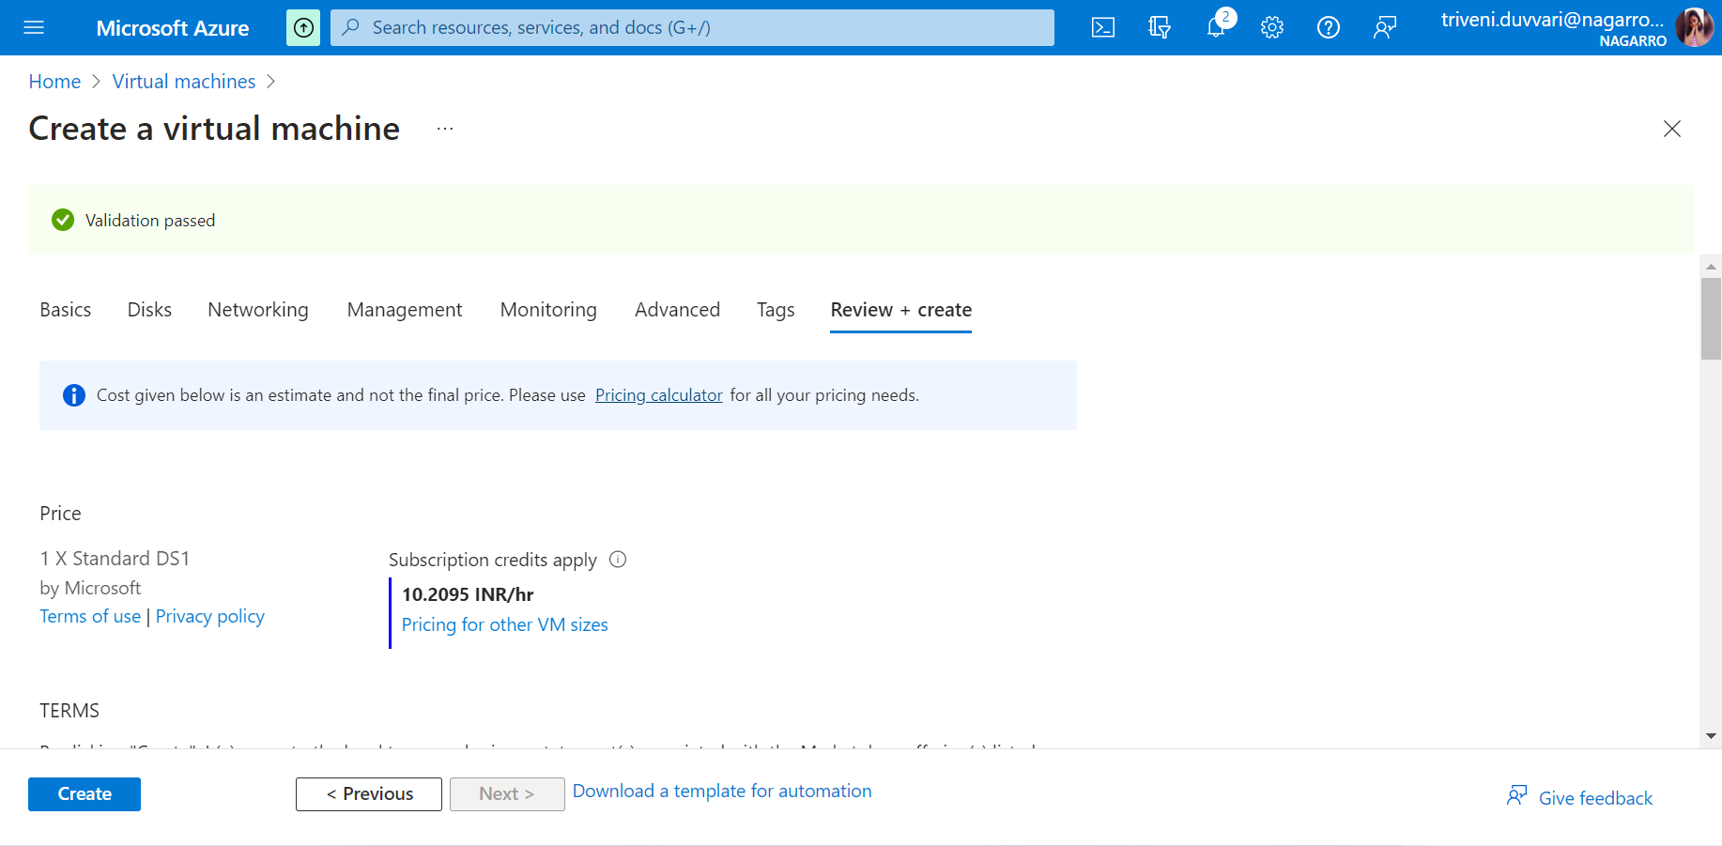

Click on Create

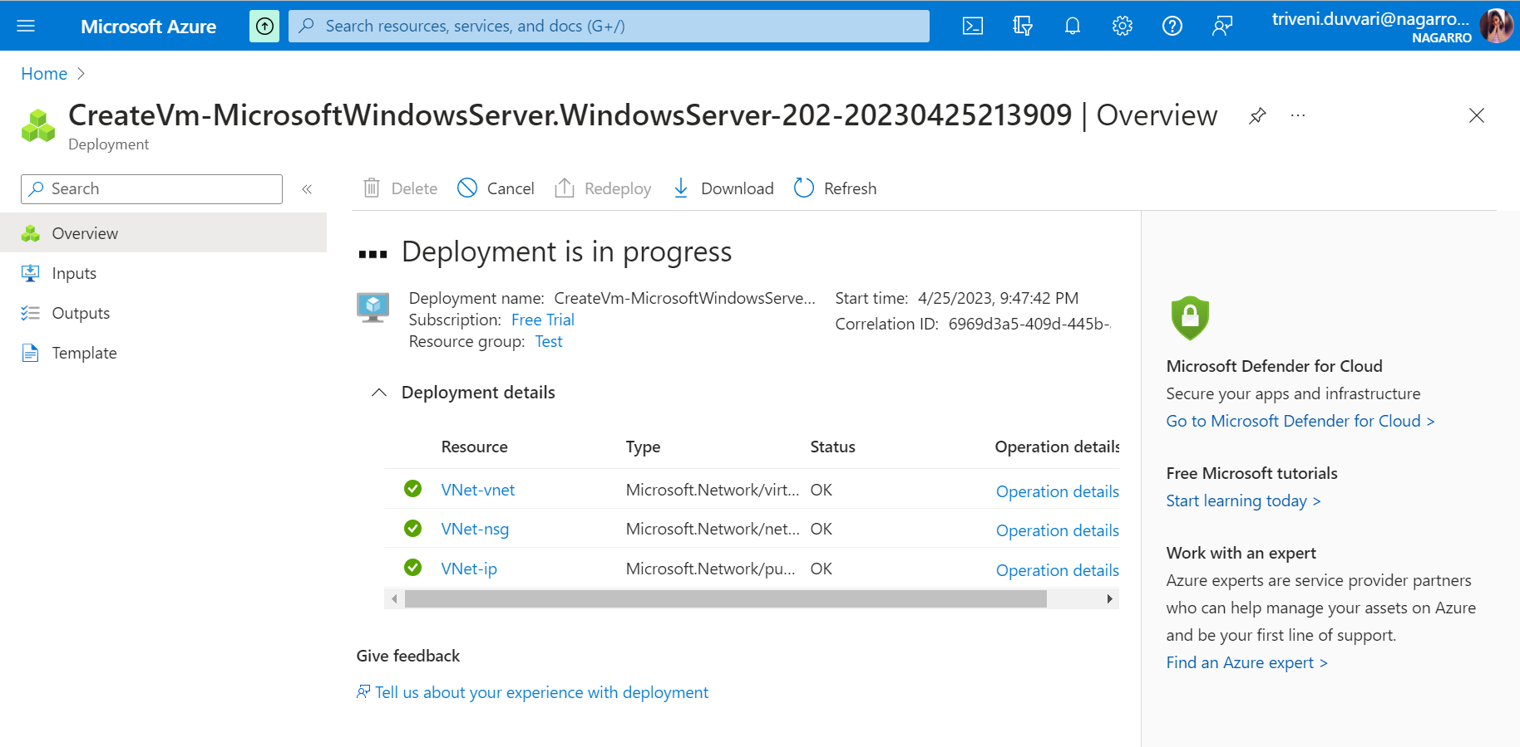

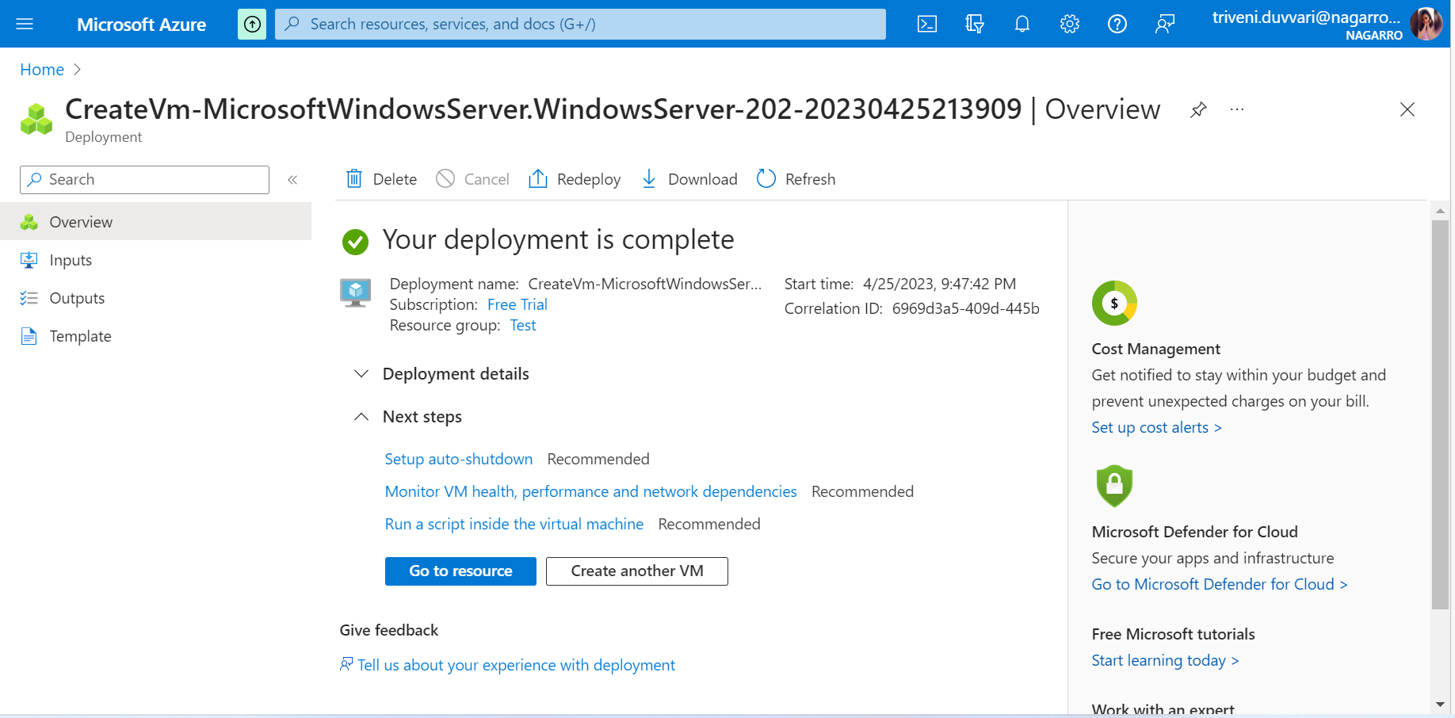

3.Deploy the same application to Azure App Service. It should also leverage the database on the cloud.

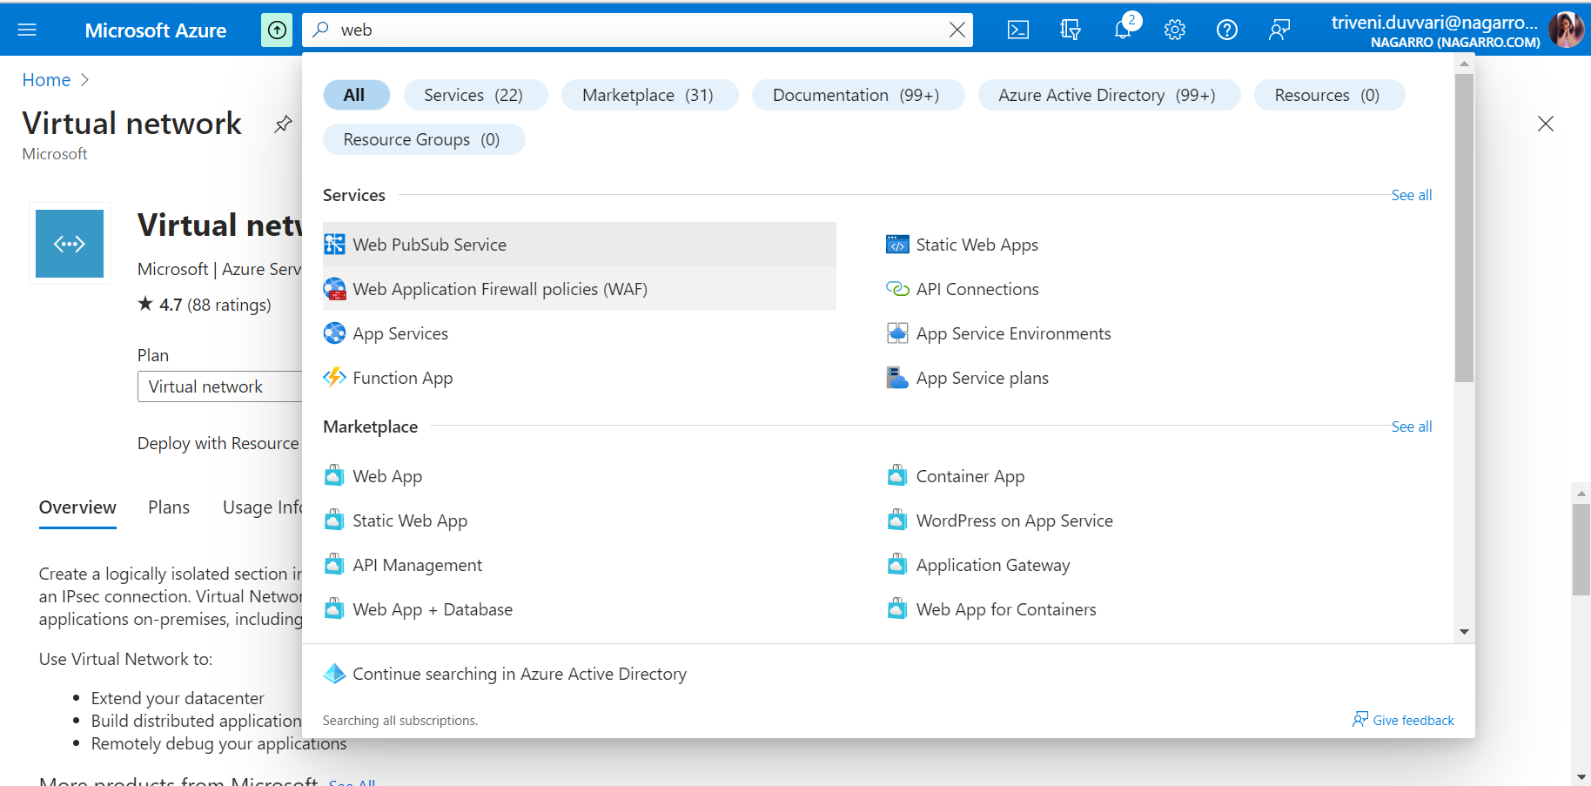

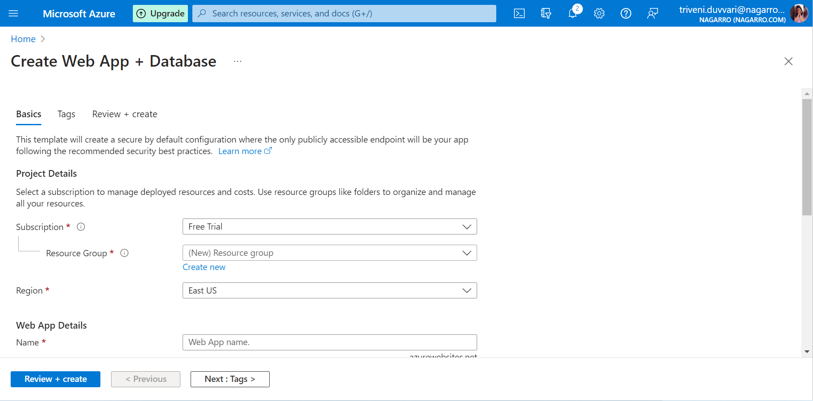

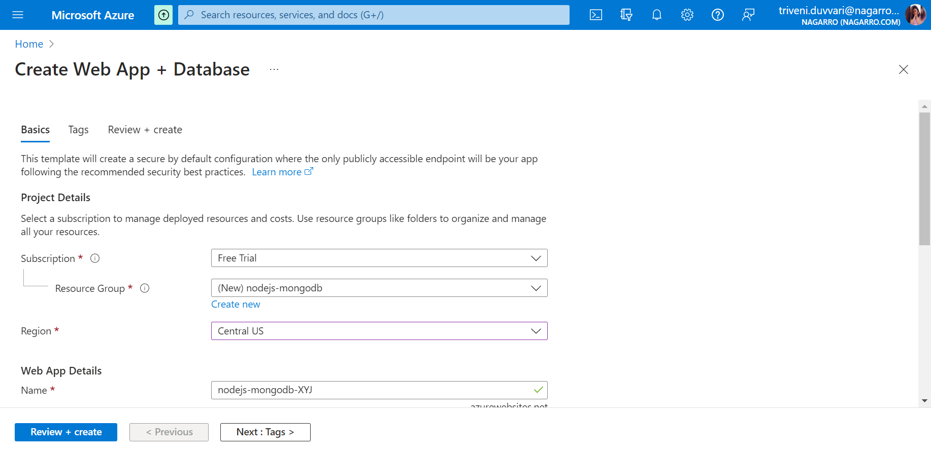

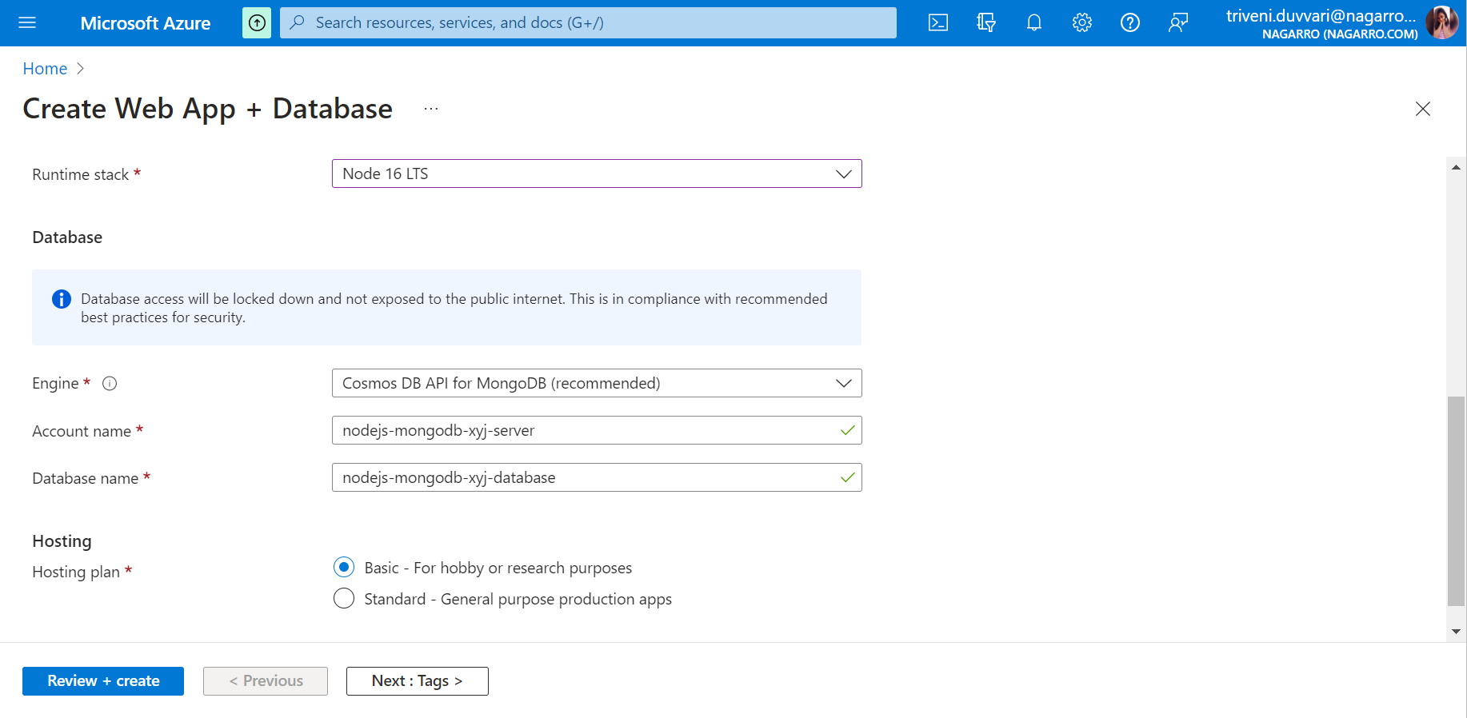

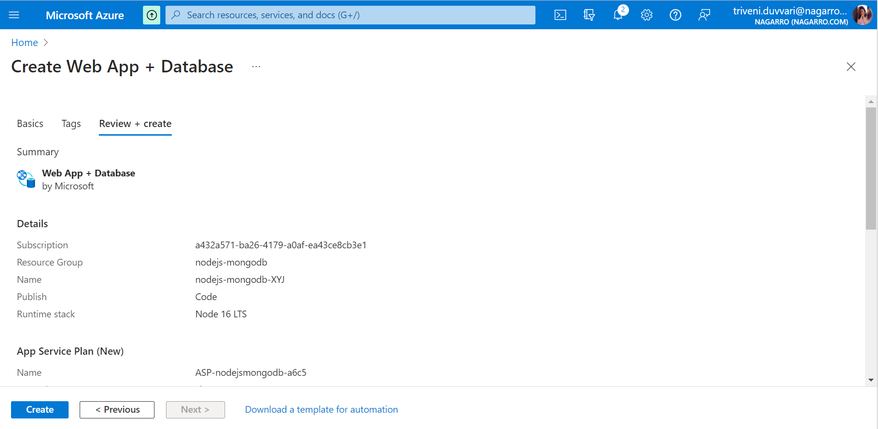

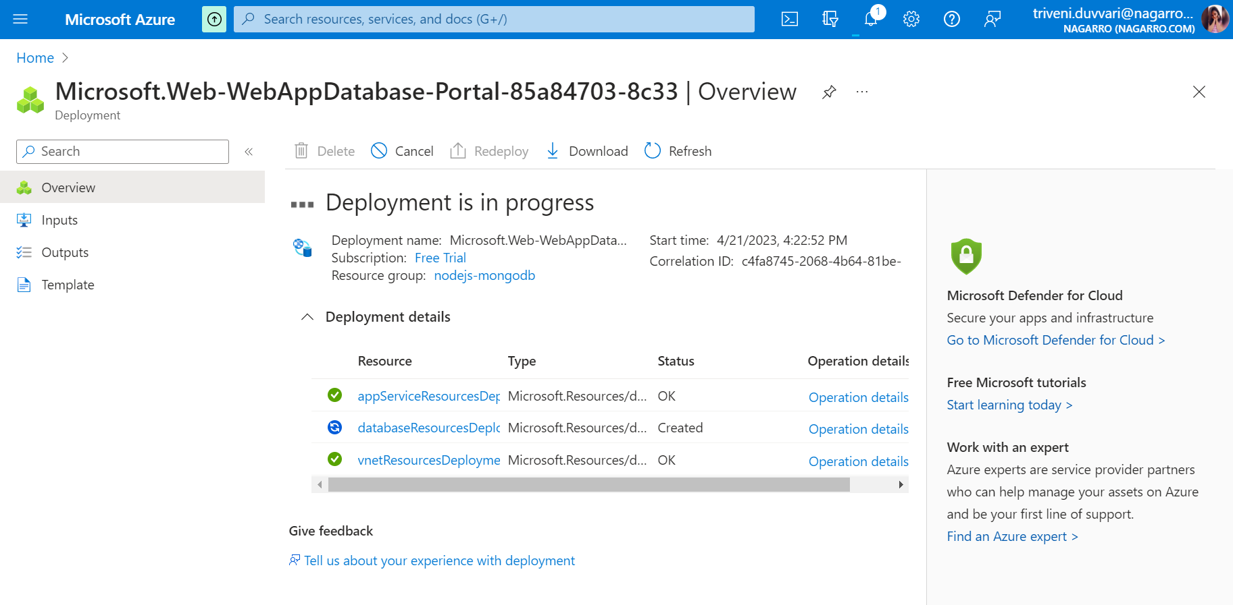

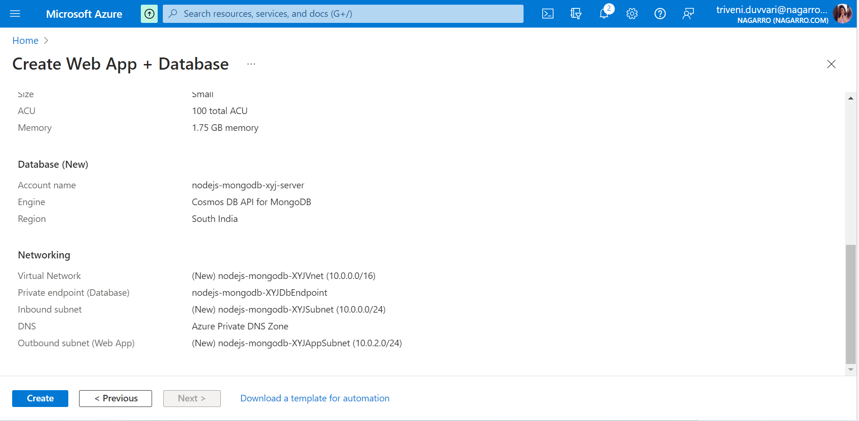

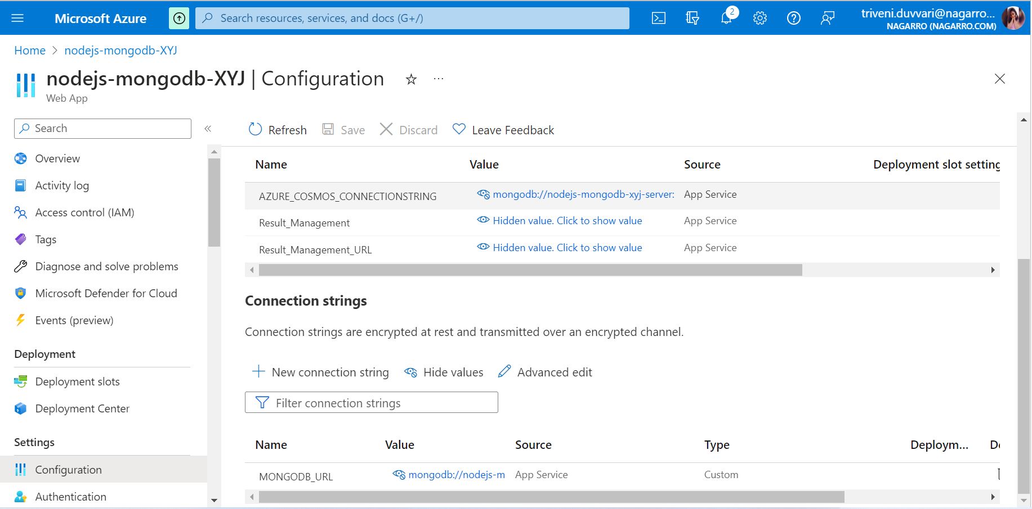

4.Create the AKS cluster (2 nodes, smallest size VM) and deploy any two services on it. Services should be accessible from the internet

Log in to the Azure portal and go to the marketplace, search Azure Kubernetes services and click on it.

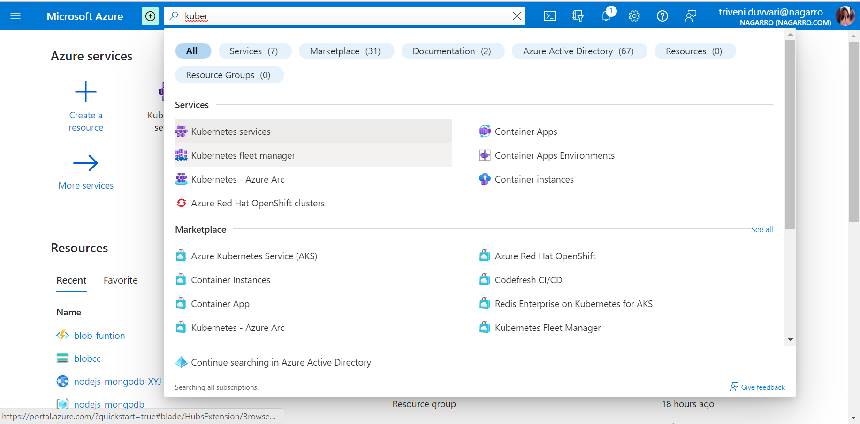

Click on Create.

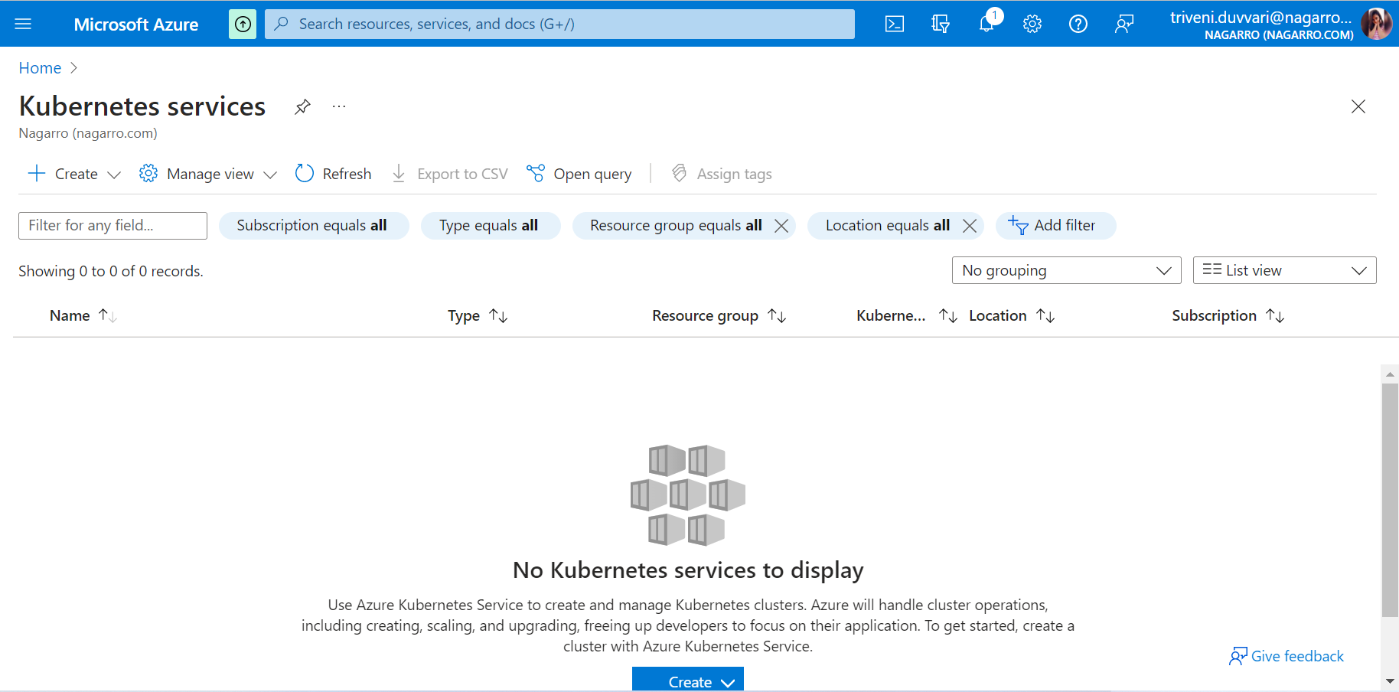

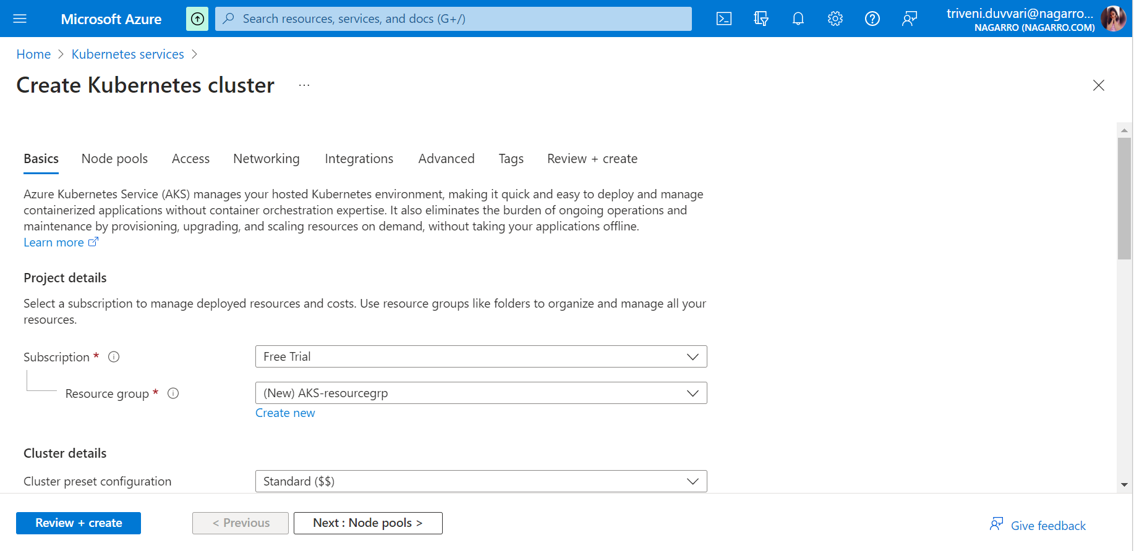

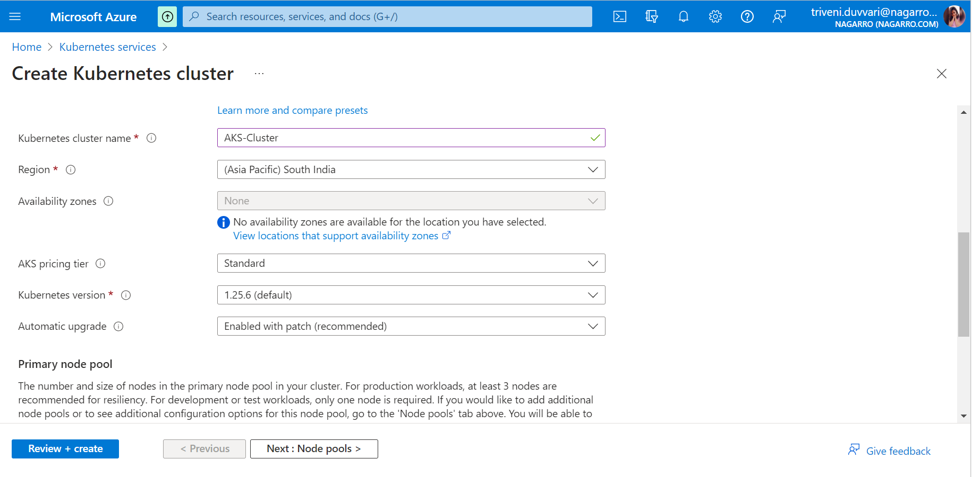

Enter resource group or create, cluster name, region, and Kubernetes version.

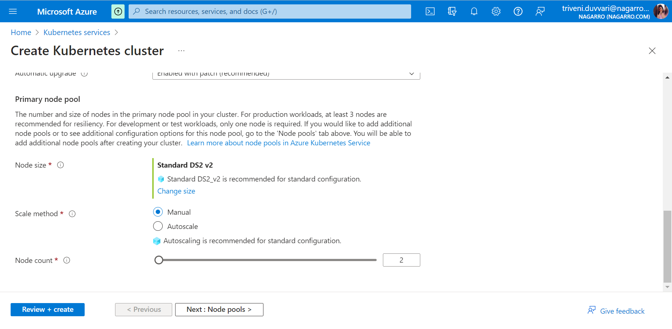

Choose the node size, and node count 2 and click on Next.

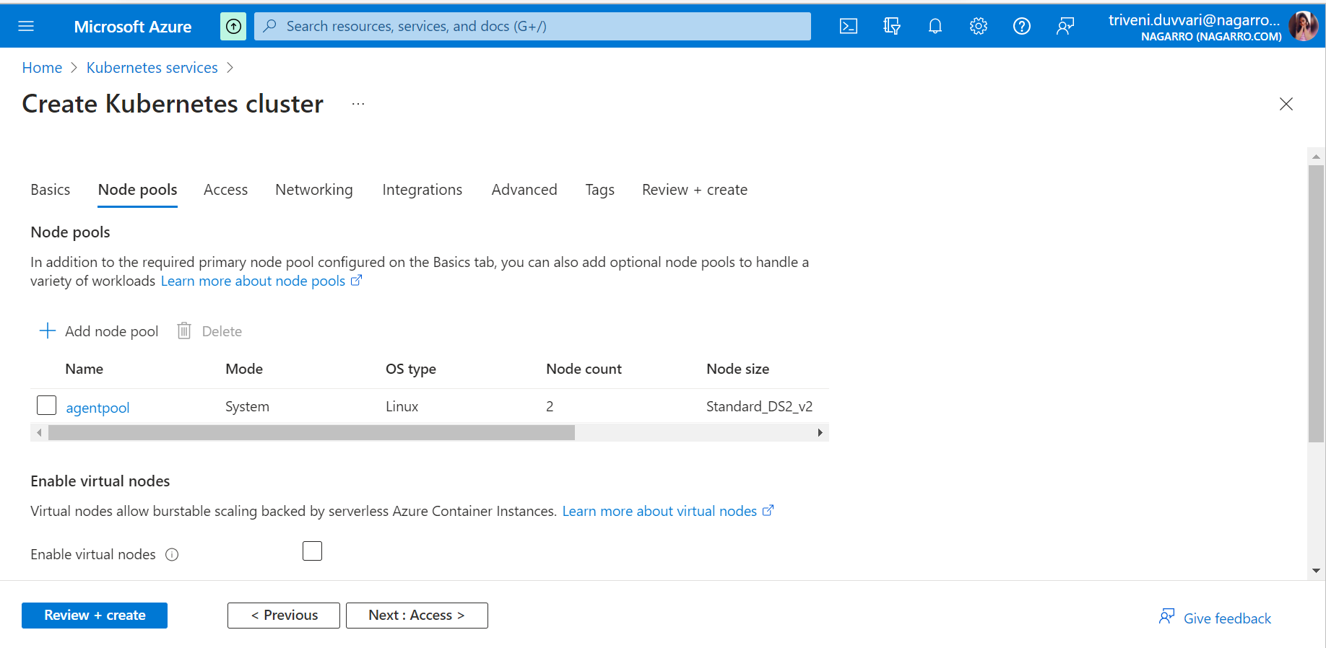

Click on Review + Create

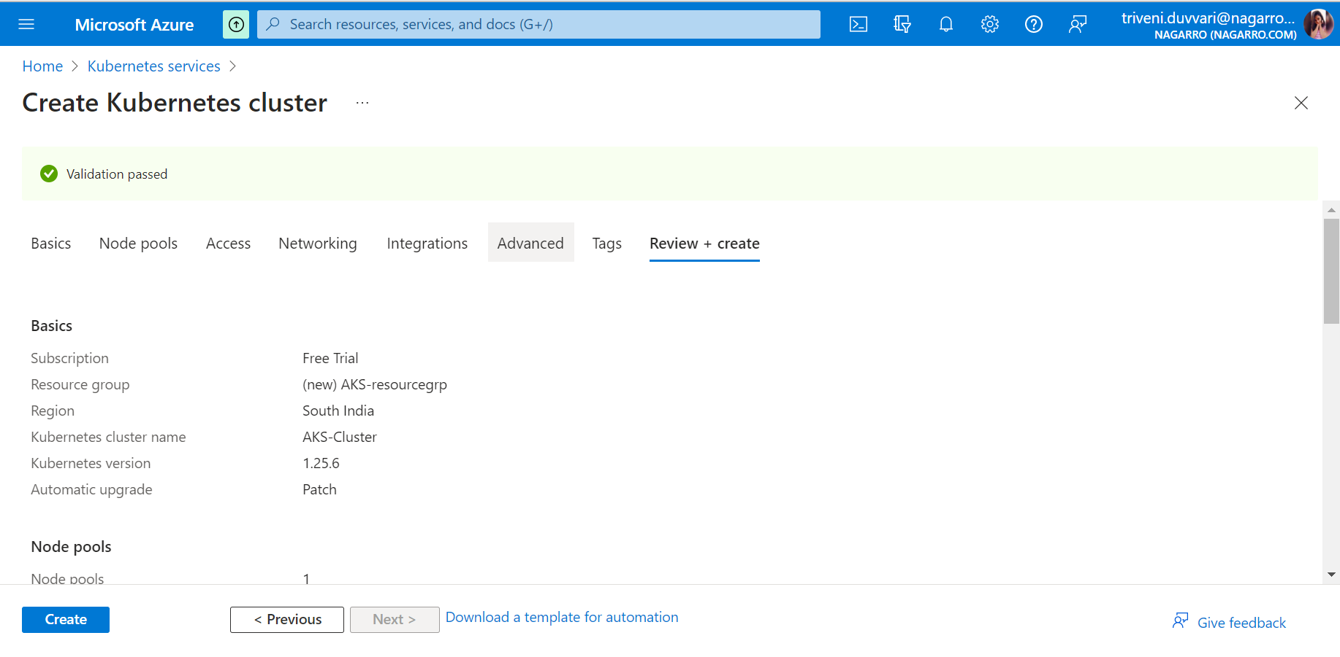

Click on Create

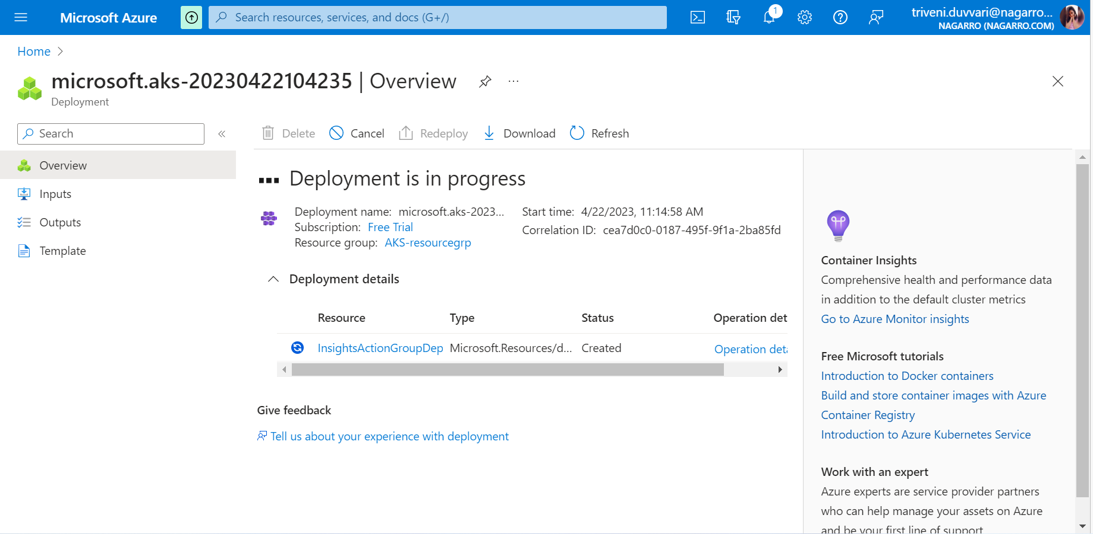

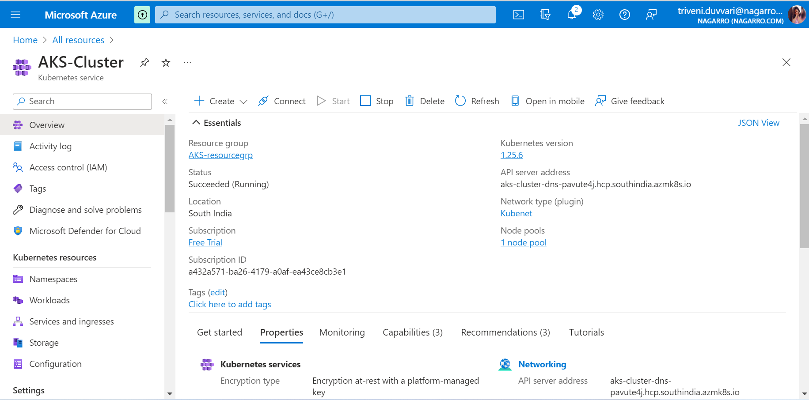

5. Create an Azure function that should trigger as soon as you upload a file in the blob storage. Function should be able to print the name of the file uploaded in the function.

**Create a storage Account**

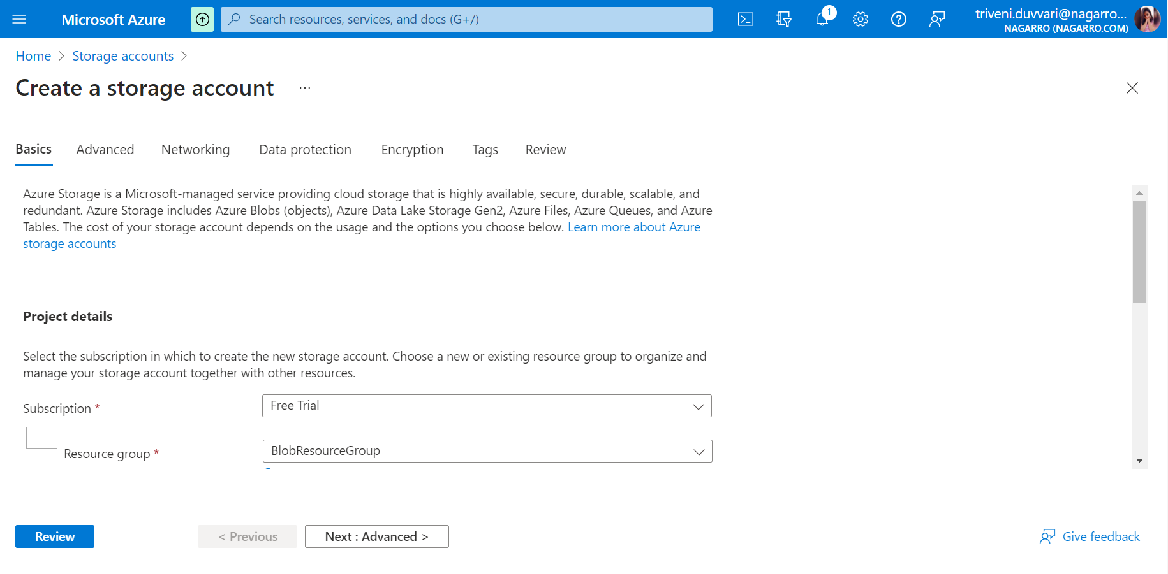



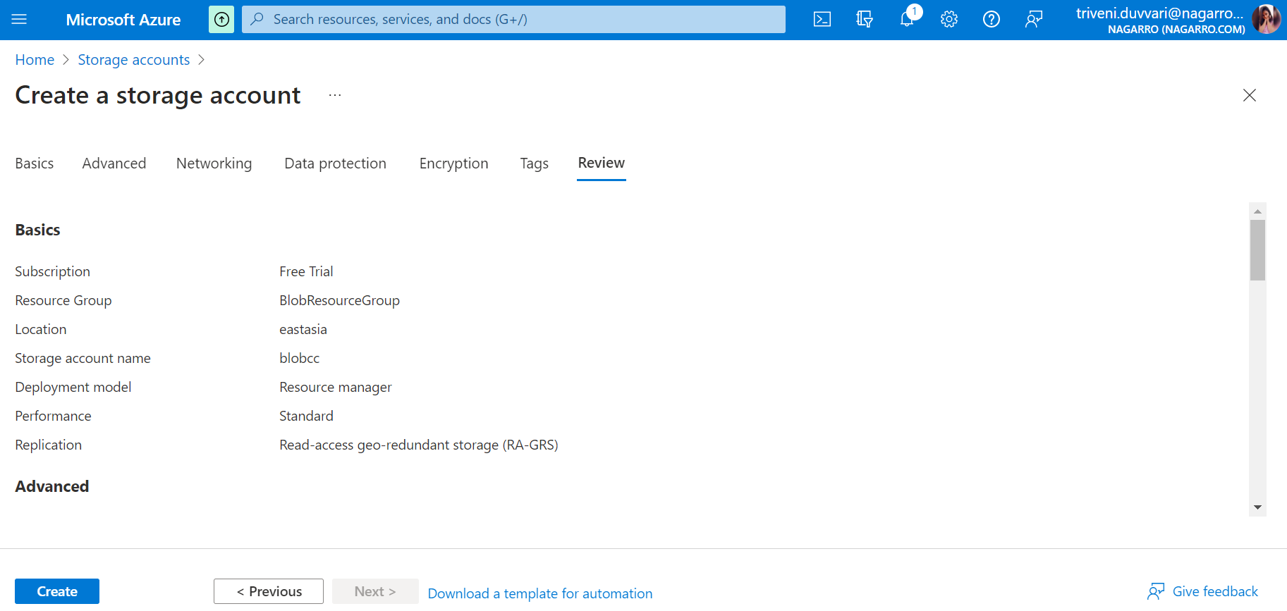

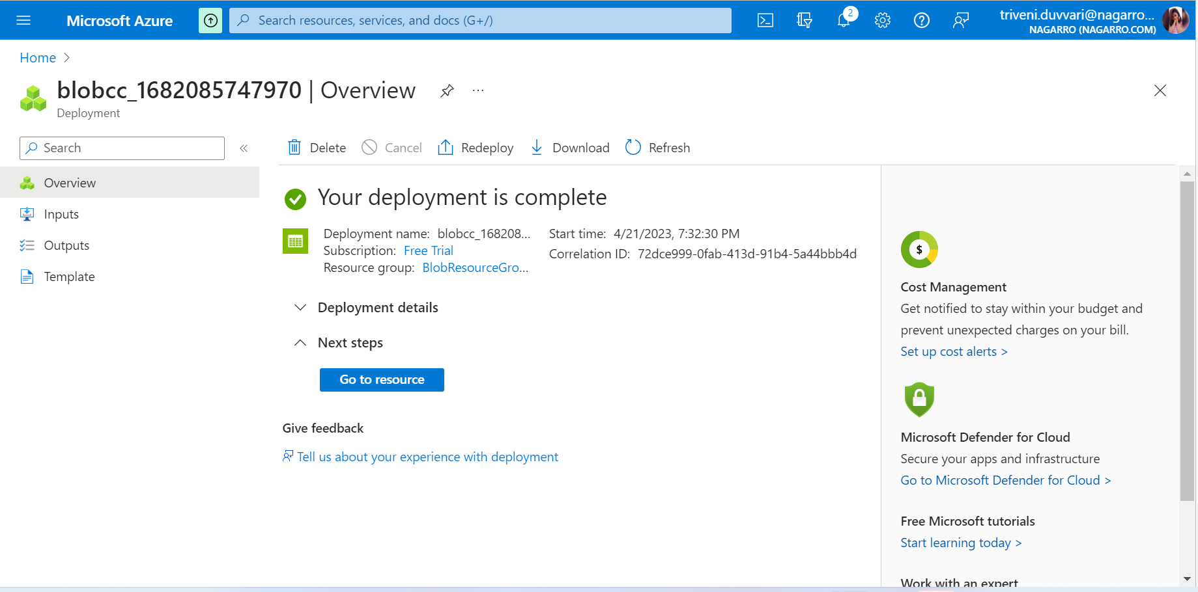

**Create Function App**

From the Azure portal menu or the **home** page, select **Create a resource.**

In the **New** page, select **Compute > Function App**.

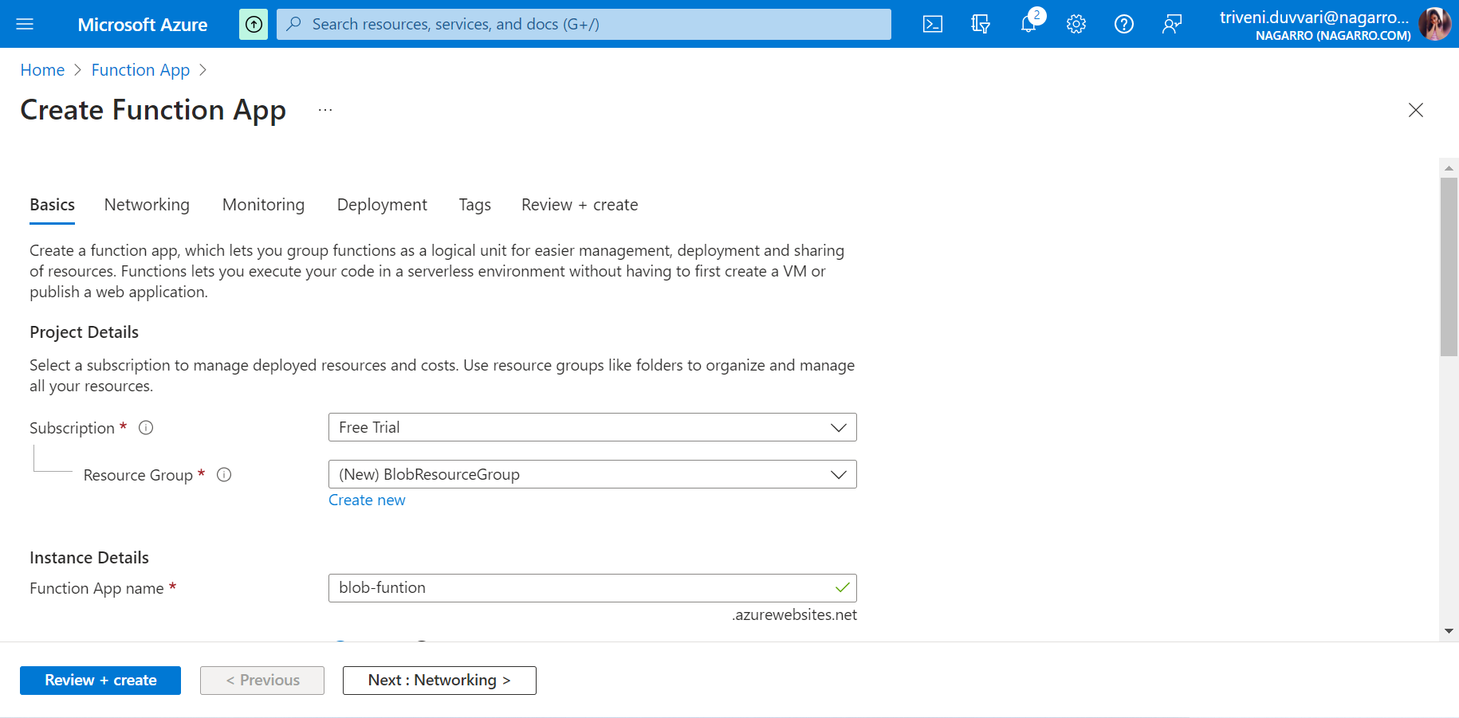

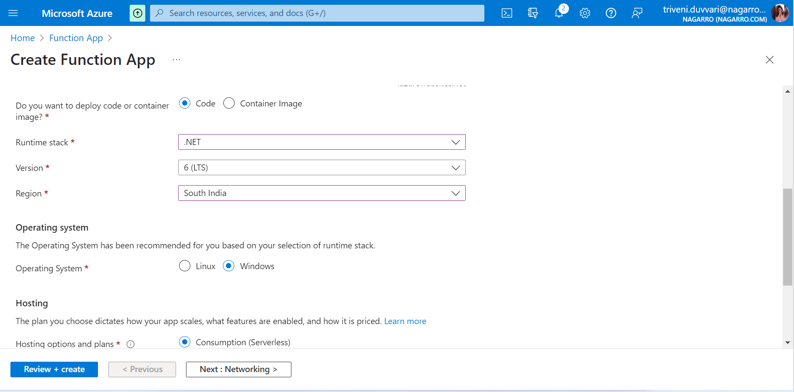

Fill the basic information and click on Next:Networking

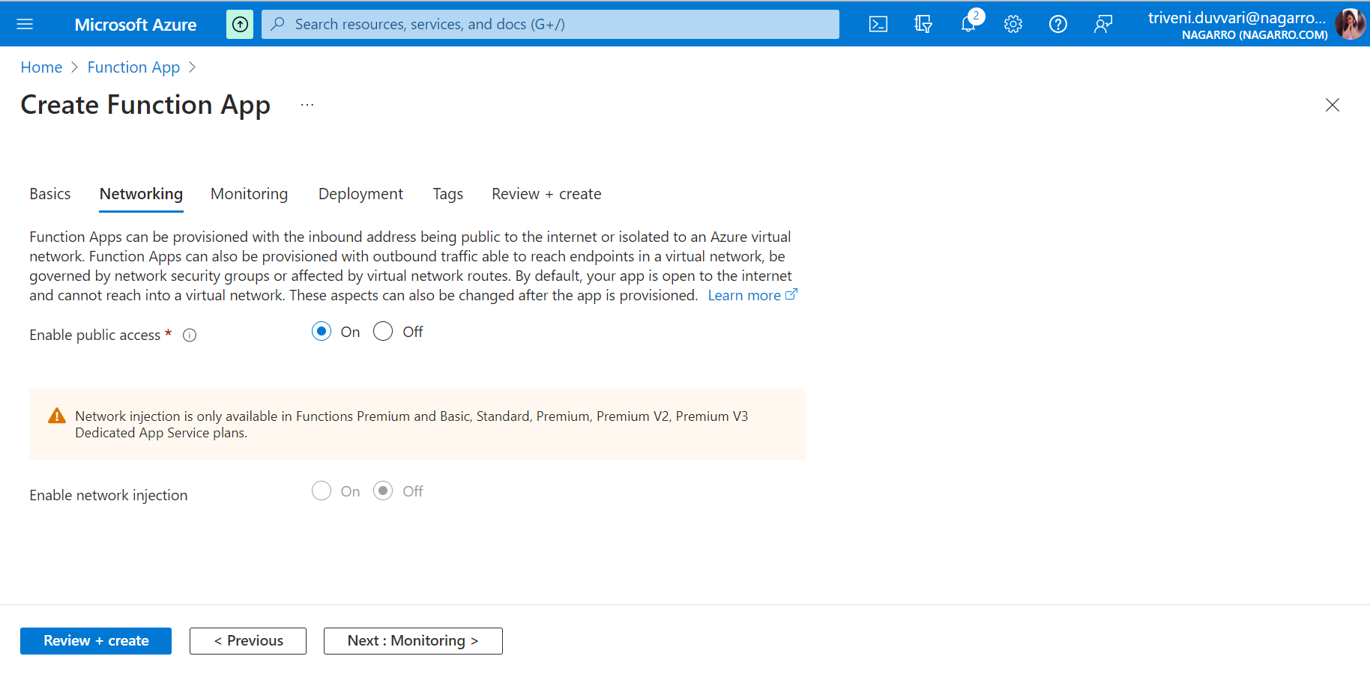

Click on Next: Monitoring

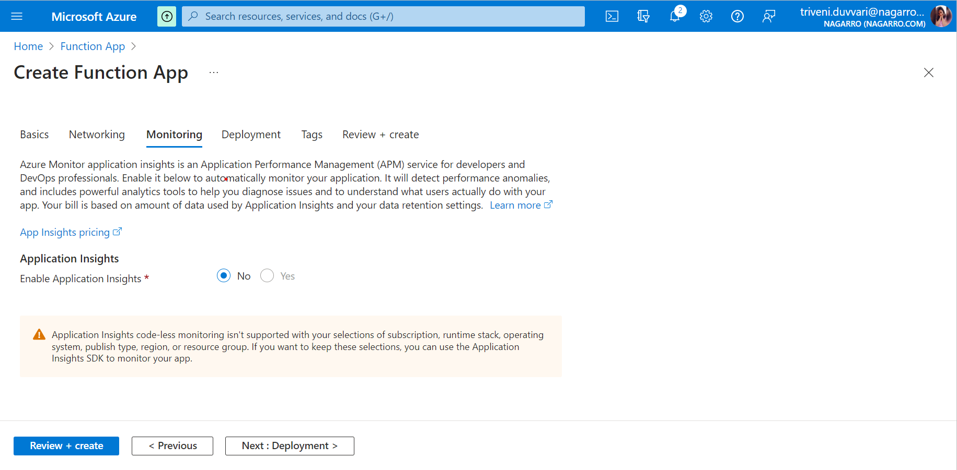

Click on Review + Create

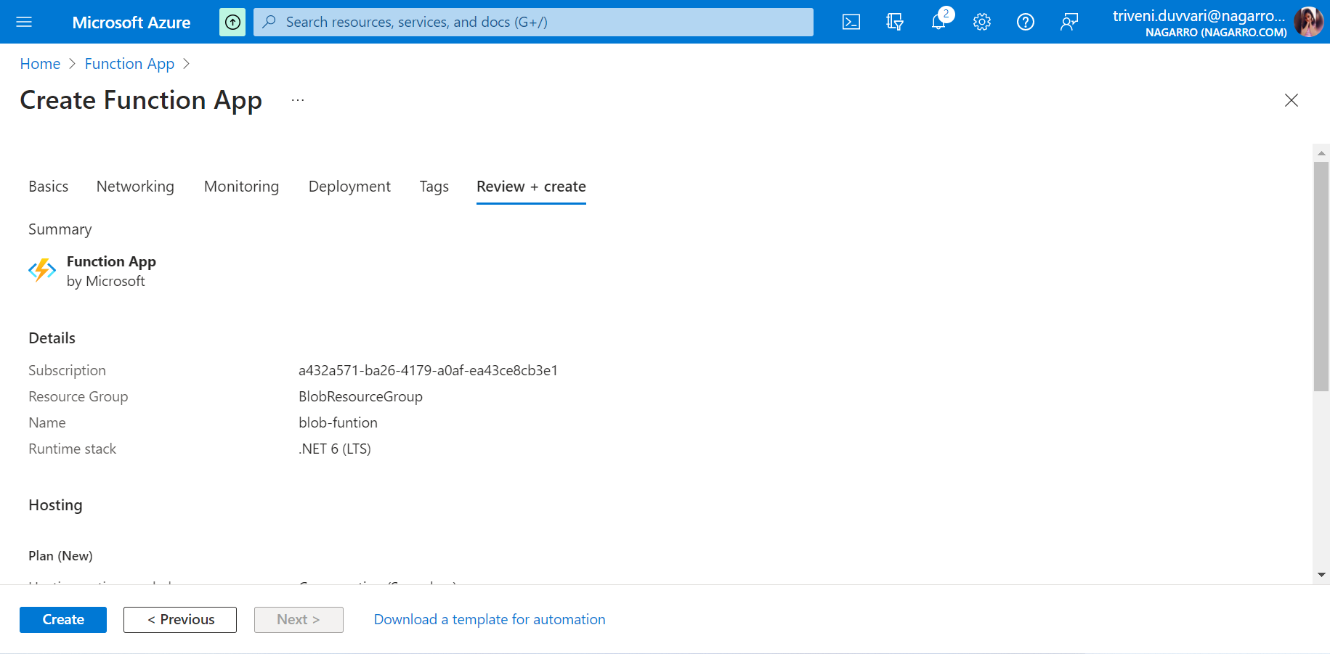

Click on Create

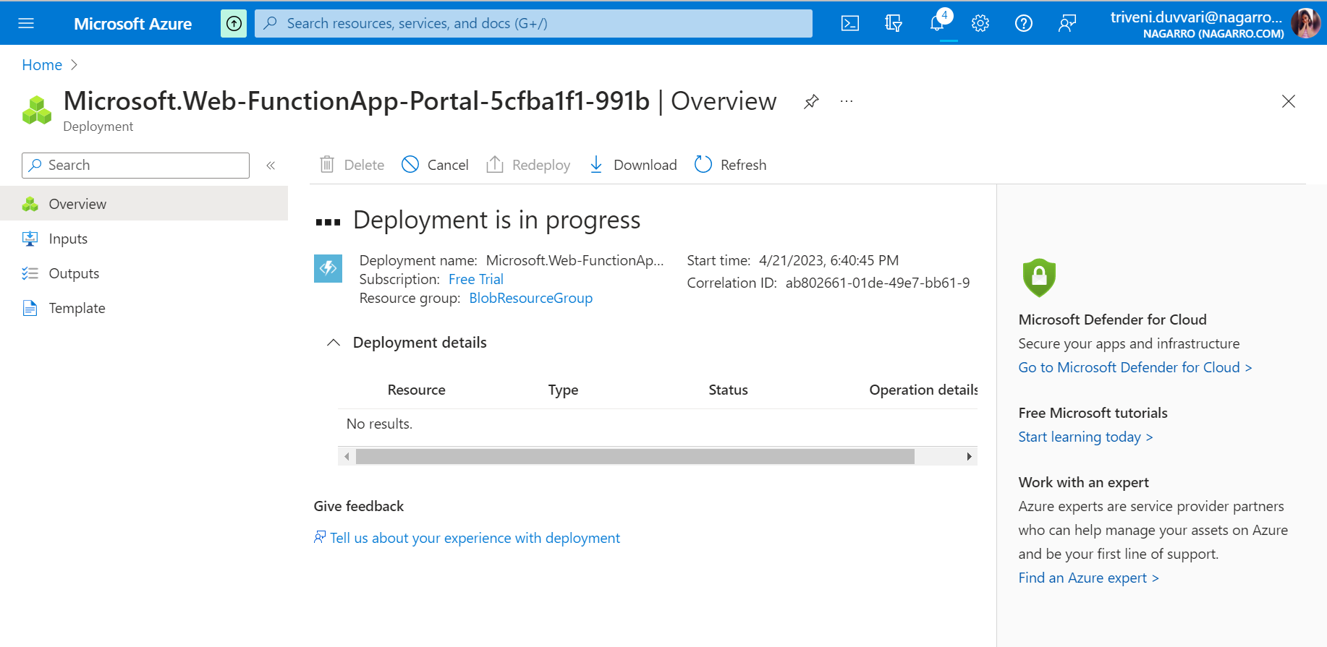

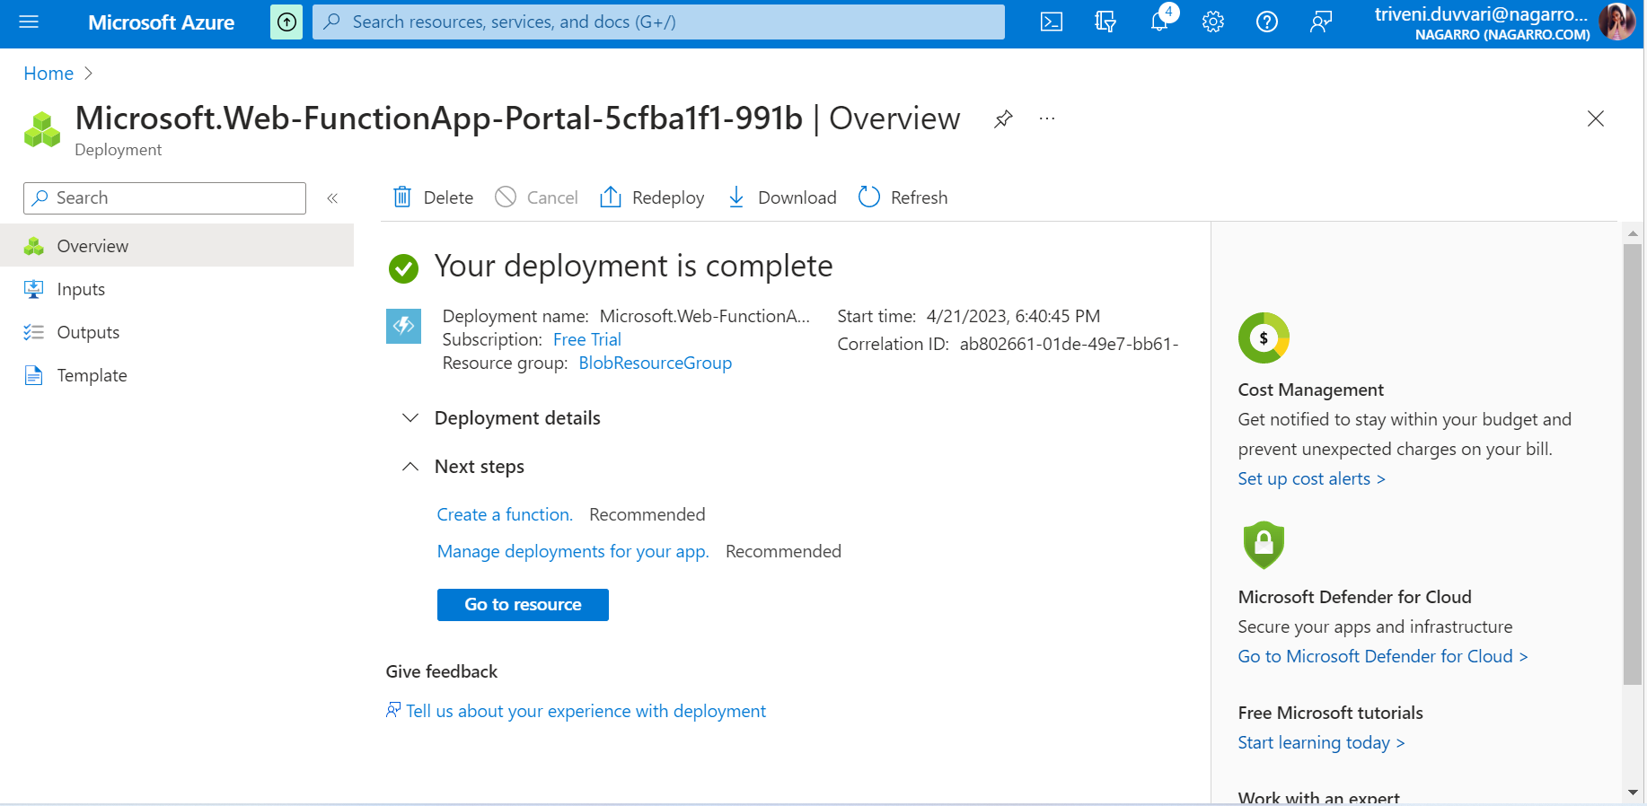

## For Blob storage triggered function, Click on Go to Resource

## Create Blob storage triggered function

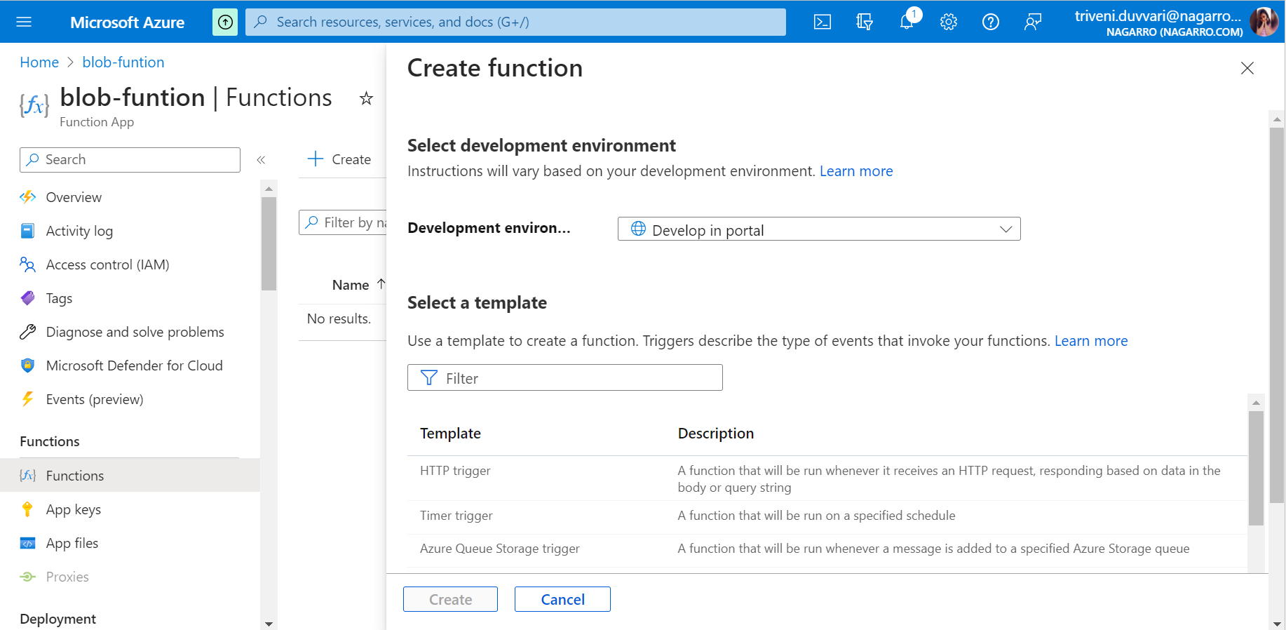

Click in Functions in left panel and create

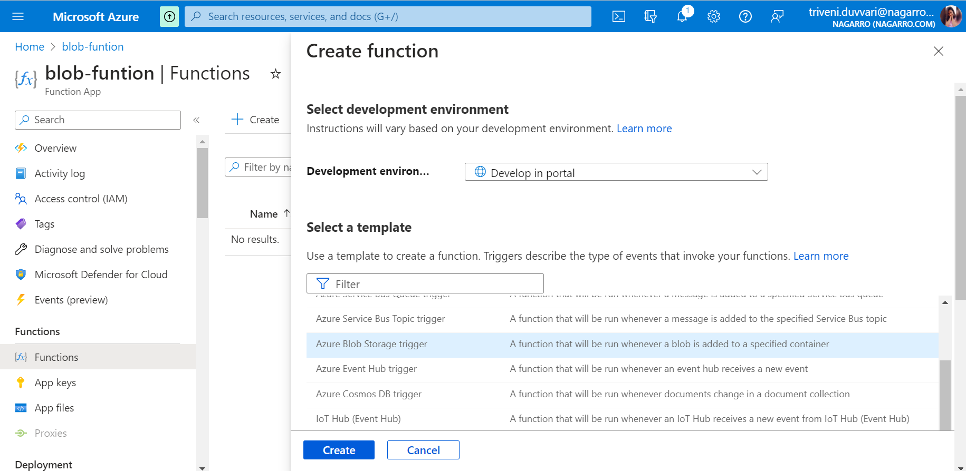

Select the Azure Blob storage trigger template

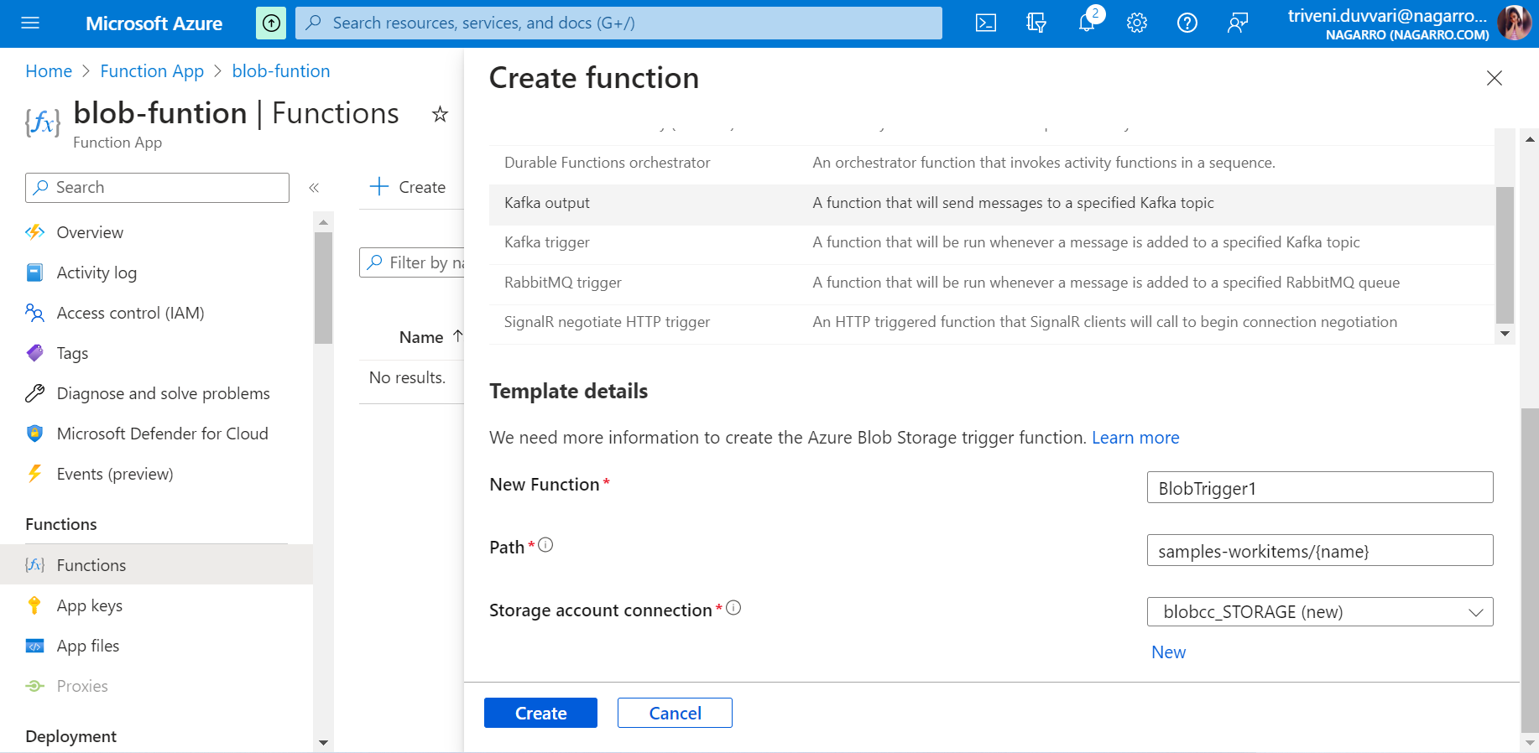

Fill the template details and for storage account connection, use the storage created.

Click on Create

**Create the container**

In function, on the **Overview** page, select resource group.

Find and select resource group's storage account.

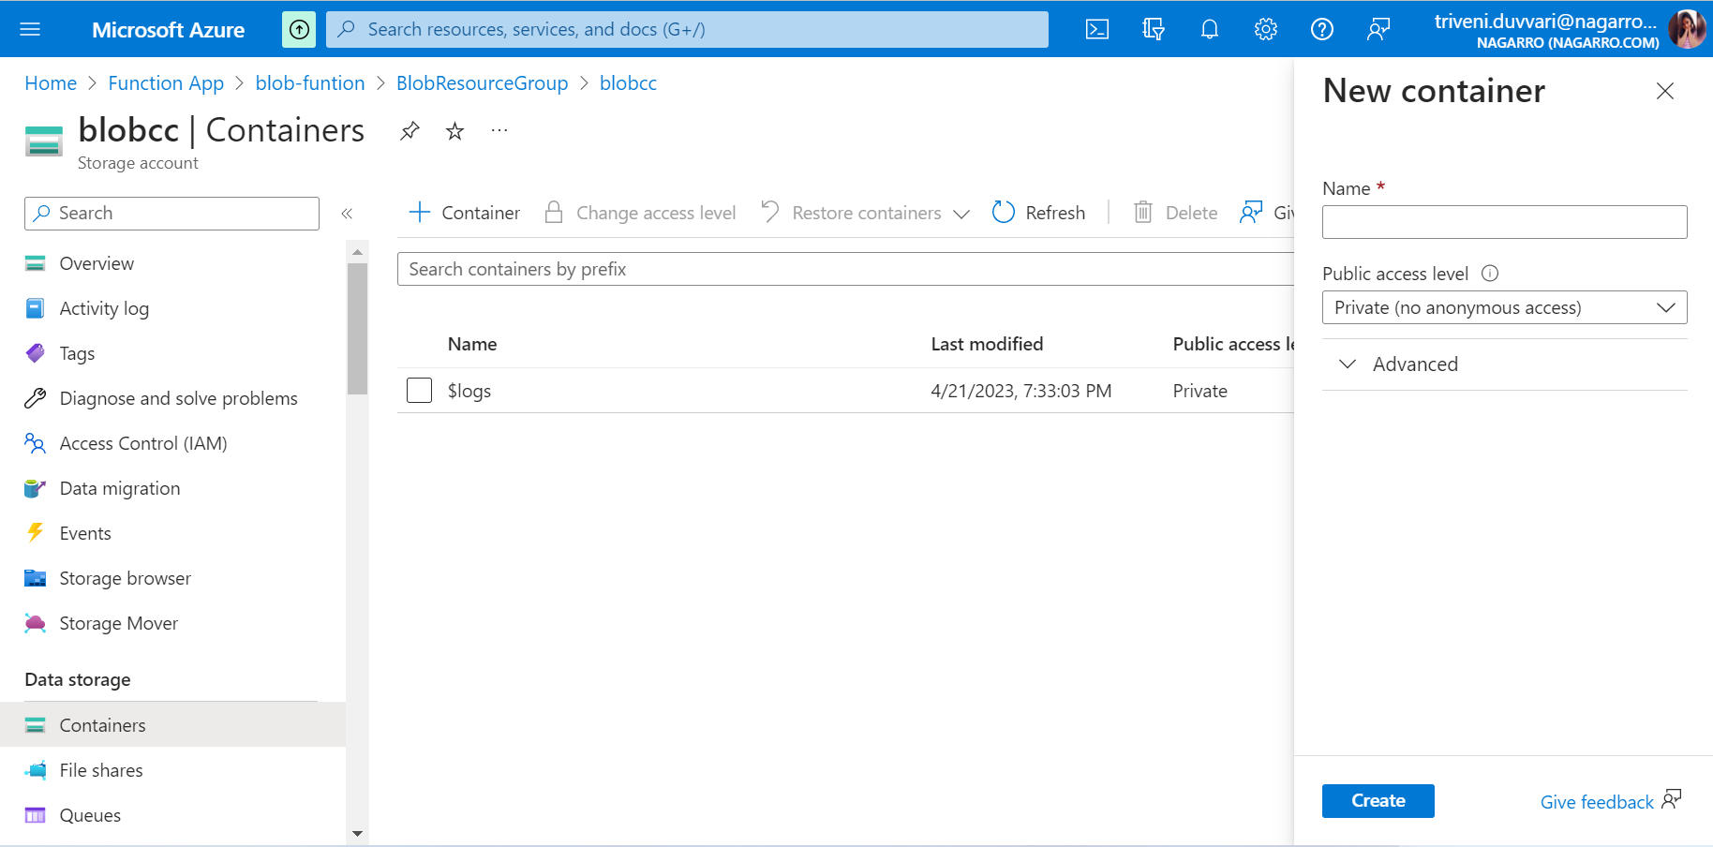

Choose **Containers**, and then choose **+ Container**

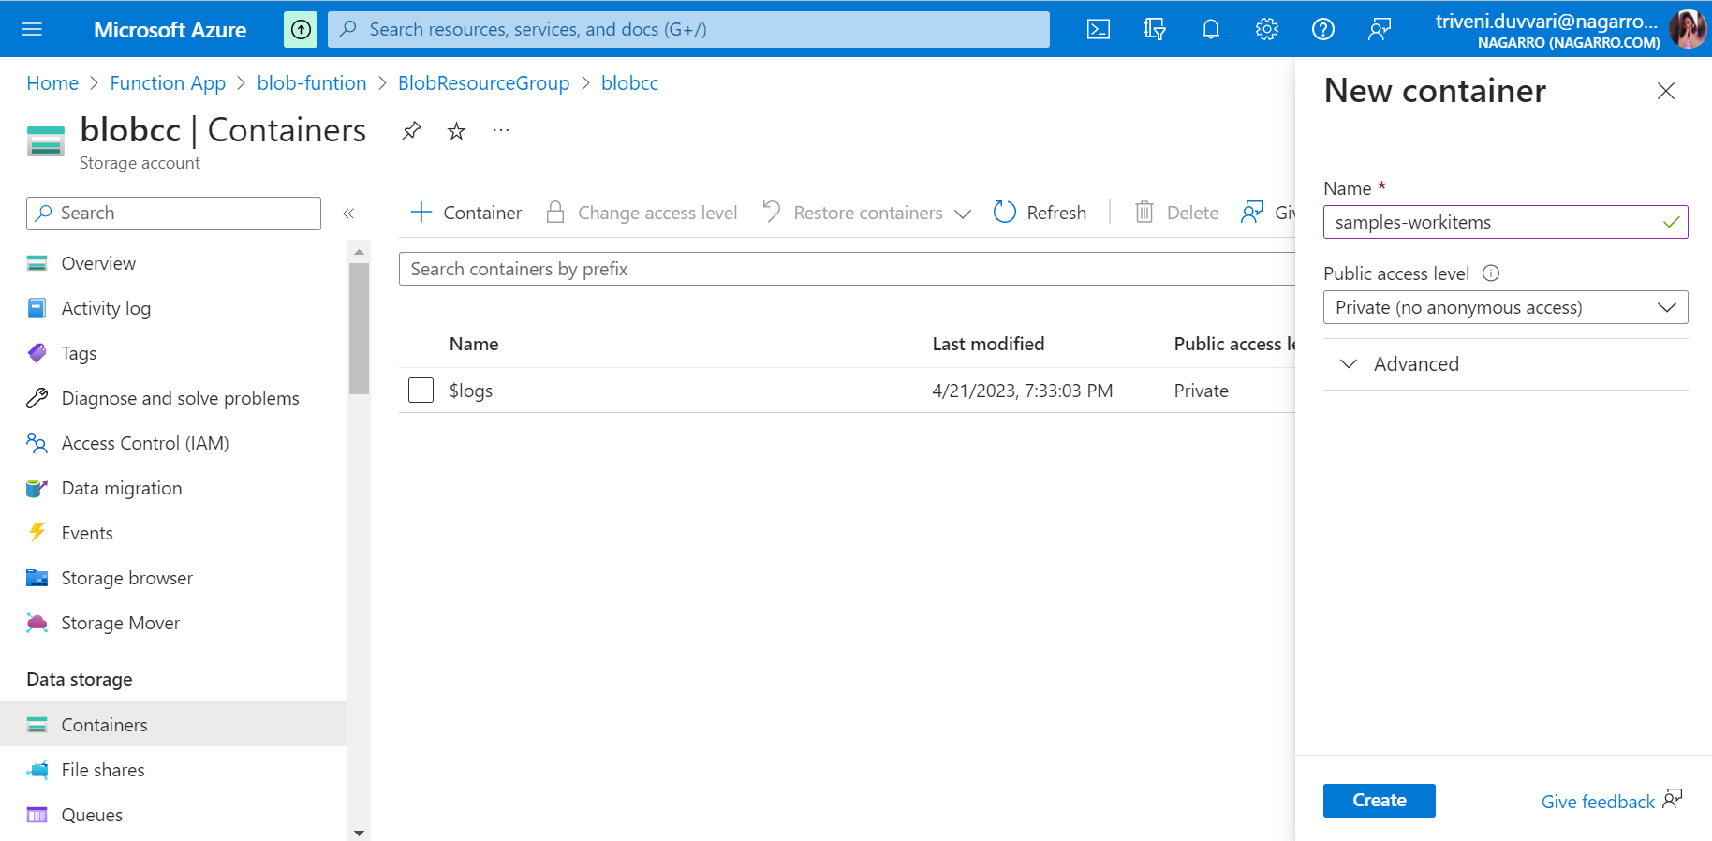

Fill the details and click on Create

**Test Function**

Back in the Azure portal, browse to your function expand the **Logs** at the bottom of the page and make sure that log streaming isn't paused

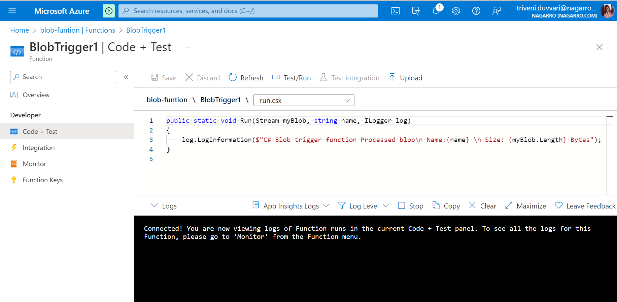

In a separate browser window, go to your resource group in the Azure portal, and select the storage account.

Select **Containers**, and then select the **samples-workitems** container.

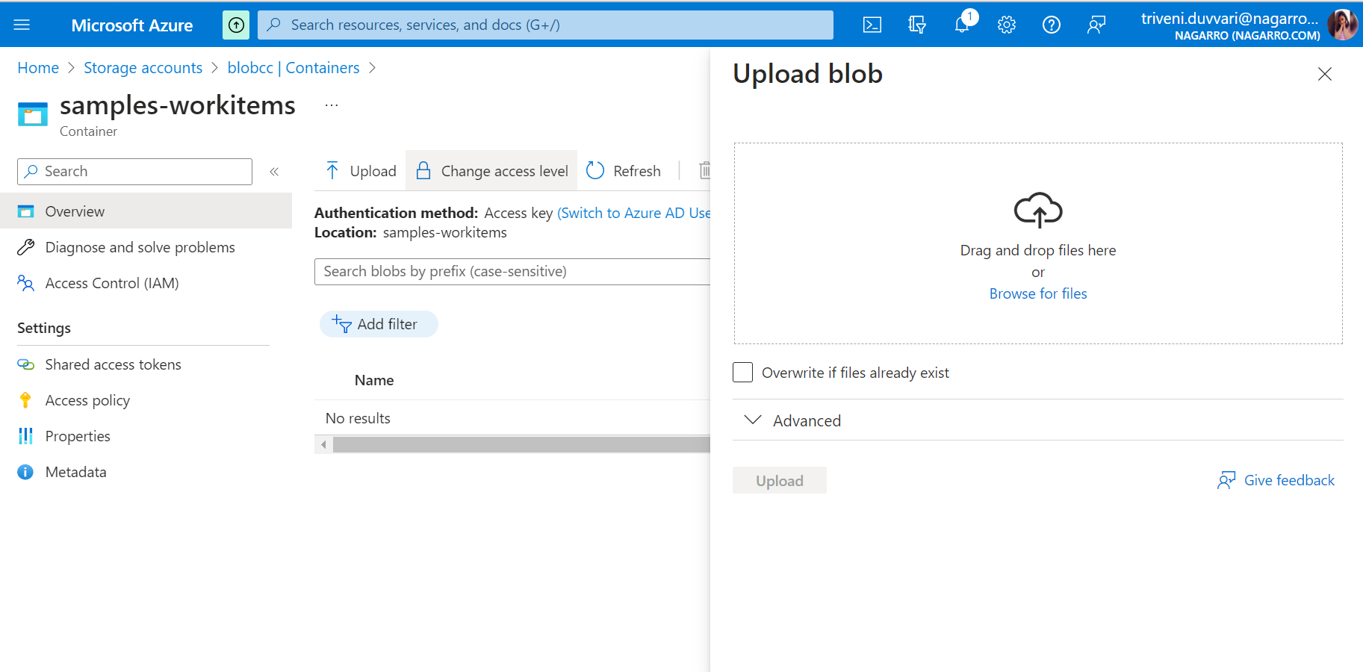

Browse to a file on your local computer, such as an image file, choose the file. Select **Open** and then **Upload**.

Go back to your function logs and verify that the blob has been read.